

A MINI PROJECT REPORT

On

HOSTELDEKHO.COM

|  |  |  |
| --- | --- | --- |
|  | **Submitted by** |  |
| **Bhavy Gupta**  **Roll No: 194200037** |  | **Yug Garg**  **Roll No: 194200162** |
| **Vaseem Khan**  **Roll No: 194200146** |  | **Yash Raj**  **Roll No: 194200157** |
| **Vinayak Jaiswal**  **Roll No: 194200147** |  | **Raunak Agarwal**  **Roll No: 194200106** |

**Under the Guidance of**

### Mr. Gaurav Sharma (Assistant Professor)

Department of Computer Engineering & Applications

## Institute of Engineering & Technology

### GLA University Mathura- 281406, India

**June, 2021**

We hereby declare that the work which is being presented in the B.C.A. Project **“HOSTELDEKHO.COM”**, in partial fulfillment of the requirements for the award of the ***Bachelor of Computer Applications*** and submitted to the Department of Computer Engineering and Applications of GLA University, Mathura, is an authentic record of our own work carried under the supervision of **Mr. Gaurav Sharma, Assistant Professor of Computer Engineering & Applications Department.**

The contents of this project report, in full or in parts, have not been submitted to any other institute or university for the award of any degree.

|  |  |  |
| --- | --- | --- |
| Bhavy Gupta (194200037) |  | Yug Garg (194200162) |
| Vaseem Khan (194200146) |  | Yash Raj (194200157) |
| Vinayak Jaiswal (194200147) |  | Raunak Agarwal (194200106) |

#### This is to certify that the above statements made by the candidates are correct to the best of my/our knowledge and belief.

***Project Supervisor Date:***

(**Mr. Gaurav Sharma**)

***Project incharge***

(**Mr. D.P Yadav**)

***Program Coordinator***

**(Mr. Narendra Mohan)**

***Head of Department***

(**Prof. Anand Singh Jalal**)

The satisfaction which accompanies the successful completion of the project is incomplete without the mention of a few names. We take this opportunity to acknowledge the efforts of the many individuals who helped us to make this project possible.

Firstly, we would like to express our heartfelt appreciation and gratitude to our project guide **Mr. Gaurav Sharma, Assistant Professor, Computer Engineering & Applications Department.** His vision and execution aimed at creating a structure, definition and realism around the project and fostered the ideal environment for us to learn and do. This project is a result of his teaching, encouragement and inputs in the numerous meetings he had with us, despite his busy schedule.

We would also like to extend our immense gratitude to respected Head of Department **Prof. Anand Singh Jalal** who allowed us to choose the topic for our dissertation.

The experience was novel one and we would like to thank all the people, who have let their valuable time for the completion of the report. Without their consideration it would have been difficult to complete the report.

|  |  |
| --- | --- |
| Bhavy Gupta | (194200037) |
| Yug Garg | (194200162) |
| Vaseem Khan | (194200146) |
| Yash Raj | (194200157) |
| Vinayak Jaiswal | (194200147) |
| Raunak Agarwal | (194200106) |

HOSTELDEKHO.COM is a website. This website will help the people to find the hostels nearby GLA UNIVERSITY. Through this website people can book the room online in just few minutes. This website shows the lowest price of a room with full comfortable facility. Anyone can book a room at any time and from anywhere. Admin has the access on the database of the system. Admin can see the room requests of the people and allot the room when the customer is comfortable with the room at the time when customer visits to the hostel.

There are 2 users:

Admin

Common User

Anyone can login or signup in the system by providing few details. After login one can see the different Hostels with rooms images which are available on the system. According to their comfort, they can simply book the hostel. It can save the time of the people who are busy in their schedules.

# TABLE OF CONTENTS

|  |  |
| --- | --- |
| **TOPIC** | **PAGE NO.** |
| Declaration | II |
| Certificate | III |
| Acknowledgement | IV |
| Abstract | V |
| List of Tables | VIII |
| List of Figures | VIII |
| Chapter 1 Introduction | 1 |
| 1.1 Overview & Motivation | 1 |
| 1.2 Objectives | 2 |
| 1.3 Organization of Project Report | 2 |
| Chapter 2 Software Requirement Analysis | 3 |
| 2.1 Requirement Analysis | 3 |
| 2.1.1 Hardware Requirement | 4 |
| 2.1.2 Software Requirement | 4 |
| 2.1.3 Tools & Technologies | 4 |
| 2.2 Feasibility Test | 5 |
| 2.2.1 Technical Feasibility | 5 |
| 2.2.2 Operational Feasibility | 6 |
| 2.2.3 Economical Feasibility | 7 |
| 2.3 Analysis | 8 |
| 2.4 Summary of Modules | 8 |

|  |  |
| --- | --- |
| Chapter 3 Software Design | 10 |
| 3.1 DFD | 11 |
| 3.1.1 DFD Level 0 | 12 |
| 3.1.2 DFD Level 1 | 12 |
| 3.2 Entity Relationship Diagram | 13 |
| ER Diagram | 14 |
| 3.3 Database Design | 17 |
| Chapter 4 Implementation & User Interface | 21 |
| Chapter 5 Software Testing | 37 |
| 5.1 Testing | 37 |
| 5.2 Objectives of Software Testing | 37 |
| 5.3 Principles of Software Testing | 38 |
| White Box Testing | 38 |
| Black Box Testing | 38 |
| 5.4 Testing Fundamentals | 39 |
| 5.5 Testing Information | 39 |
| Conclusion | 40 |
| Bibliography & References | 41 |

**LIST OF TABLES**

|  |  |  |  |
| --- | --- | --- | --- |
| **S.No.** | **Table Name** | **Table No.** | **Page No.** |
| 1. | Admin Login Table | Table 3.1 | 17 |
| 2. | Booking Table | Table 3.2 | 18 |
| 3. | Contact Details | Table 3.3 | 19 |
| 4. | Rooms Table | Table 3.4 | 19 |
| 5. | Payment Table | Table 3.5 | 20 |
| 6. | Rooms Table | Table 3.6 | 21 |

# LIST OF FIGURES

|  |  |  |  |
| --- | --- | --- | --- |
| **S.No.** | **Figure Name** | **Fig. No.** | **Page No.** |
| 1. | Data Flow Diagram Symbols | Fig 3.1 | 11 |
| 2. | 0 Level DFD | Fig 3.2 | 12 |
| 3. | 1 Level DFD | Fig 3.3 | 12 |
| 4. | Entity Relationship Diagram | Fig 3.4 | 14 |
| 5. | Gantt Chart | Fig 3.5 | 15 |
| 6. | Home | Fig 3.6 | 22 |
| 7. | Booking Interface | Fig 3.7 | 26 |
| 8. | Admin Panel | Fig 3.8 | 30 |
| 9. | Confirming Booking | Fig 3.9 | 31 |

|  |  |  |  |
| --- | --- | --- | --- |
| 10. | Booking Confirmed Pop-up | Fig 3.10 | 31 |
| 11. | Printing Student Details | Fig 3.11 | 32 |
| 12. | Payment Portal | Fig 3.12 | 33 |
| 13. | Printing Invoice | Fig 3.13 | 33 |
| 14. | Managing Admin Access | Fig 3.14 | 34 |
| 15. | Checking Available Rooms | Fig 3.15 | 34 |
| 16. | Adding New Rooms | Fig 3.16 | 35 |
| 17. | Confirmation on Adding Room | Fig 3.17 | 35 |

**INTRODUCTION**

HostelDekho.com is website based technology which is used to search good hostels nearby GLA University. Here student is first allowed to register on the website and also login using registered details. Once registered with their address and contact details, the students may now see a variety of hostels along with their costs and priority. Also they can book their hostel using registration process and give money when they are about to join the hostel. The student will select the hostel according to their facility and comfort (like A.C., Non A.C., single seater, double seater etc.). At the time of registration user will get one-time password(OTP). After successful registration the user now gets a notification of booking confirmed on their registered mobile no. The system allows admin to maintain the records whether the rooms is filled or empty and also record of students booking hostel using website.

## Overview and Motivation:

### Overview:

The main motive of our project “HostelDekho.com” is to help those who were busy in their work/schedule. It can reduce the time and effort of students and their family.

### Motivation:

It can save students time and parents money as college hostels is costly.

Students will get hostels according to their comfort.

## Objective:

The main objective of HostelDekho.com is to provide a good hostel nearby GLA University according to their condition and satisfaction at cheap prices. With the help of this project we want those students of GLA university (who were unable to join University hostel due to high prices) to use this website and release the pressure of searching a good hostel. Another purpose for developing this website is to reduce human effort.

* 1. **Organization of Project Report:**

|  |  |
| --- | --- |
| **PHASES** | **TIME DURATION** |
| Software Requirement Specification | 2 weeks |
| System Design | 3 weeks |
| Coding | 5 weeks |
| Testing | 2 weeks |
| Documentation | 2 weeks |
| Implementation | 1 week |

# SOFTWARE REQUIREMENT ANALYSIS

HostelDekho.com is a detailed website of searching various hostels performed by a system and its relationship inside and outside the system . It is a systematic technique that defines goals and objectives the goal of the development is to deliver the system in the line with the user’s requirements, and analysis is this process.

System study has been conducted with the following objectives in mind: -

* + - Identify the client’s need.
    - Evaluate the system concept for feasibility.
    - Perform economical and technical analysis.
    - Allocate functional to hardware, software, people, database and other system elements.
    - Establish cost and schedule constraints.
    - Both hardware and software expertise is required to successfully attain the objectives.

### Requirement Analysis:

Collecting Information about project is usually the first phase of the software development project. The purpose of this phase is to identify and document the exact requirements for the system. The user’s request identifies the need for a new information system and on investigation re-defined the new problem to be based on MIS, which supports management. The objective is to determine whether the request is valid and feasible before a recommendation is made to build a new or existing manual system continues.

The major steps are –

* + - Defining the user requirements.
    - Studying the present system to verify the problem.
    - Defining the performance expected by the candidate to user requirement.

### Hardware Requirements

|  |  |
| --- | --- |
| Processor : | Intel Dual Core or more |
| Processor Speed : | 1 GHZ |
| RAM : | 1 GB(Min) |
| Hard Disk : | 20 GB of free space |

* + 1. **Software Requirements**

**Operating System** : Window 7 and higher

Front End: HTML, CSS

Back End: SQL Server, PHP

Software : Browser, Code editor , Xampp

* + 1. **Tools and Technology:**

**Tools:**

* + - * Windows 7 & and higher
      * Notepad++
      * SQL Server

**Technology:**

* **SQL:** SQLis a structured query language used for querying database. MySQL is an open-source relational database management system. It will help in maintaining the customers record.
* **CSS:** CSS is cascading style sheet which is used in designing webpages and help in creativity.
* **PHP:** Hypertext Preprocessor is a server-side scripting language designed for web development but also used as a general-purpose programming language.
* **HTML:** Hypertext Markup Language is the standard markup language for creating web pages and web application. HTML elements are the building blocks of HTML pages. With HTML constructs, image and other objects, such as interactive form.

### Feasibility Test:

Feasibility study is the process of determination whether or not a project is worth doing. Feasibility studies are undertaken within tight time constraints and normally culminate in a written and oral feasibility report. I have taken a fixed time in feasibility study with co-developer. The contents and recommendations of this feasibility study helped us as a sound basis for deciding how to precede the project. It helped in taking decisions such as which software to use, hardware combinations, etc.

### Technical feasibility:

This is concerned with specifying equipment of software and hardware that will successfully satisfy the user requirements. The technical needs of the system may vary considerably, but might include:

* The facility to produce output in a given time.
* Response time under certain condition.
* Ability to produce a certain volume of transaction at a particular speed.
* In examining technical feasibility, configuration of the system is given more importance than the actual make of hardware. The configuration should give the complete picture about the system requirements. What speeds of input and output should be achieved at particular quality of printing.According to the definition of technical feasibility the compatibility between front-end and back-end is very important. In our project the compatibility of both is good. The degree of compatibility of PHP and SQL

Server 2014 is very good. The speed of output is very good when we enter the data and click button then the response time is very fast and give result very quick. This software provides facility to communicate data to distant location.

The designing of front- end of any project is very important so we selected HTML & CSS as front-end due to following reason:

* + Easy implementation of code.
  + Well define interface and database.
  + Well define hand shaking of PHPMyAdmin

At present scenario the no of backend are available but I have selected PHP My Admin because of the following number of reasons.

* + - Able to handle large data.
    - Security.
    - Robust RDBMS
    - Backup & Recovery

With the help of above requirements we were move defect of existing software . In future we can easily switch over any platform. To ensure that system does not halt in case of undesired situation or events. Problem affected of any module does not affect any module of the system. A change of hardware does not produce problem.

### Operational Feasibility:

It is mainly related to reduce Student efforts to find a good hostel according to their priority . The points to be considered are:

* + - * What changes will be brought with this software?
      * What organization structures are distributed ?
      * What new skills will be required? Do the existing staff members have these skills? If not, can they be trained in due course of time?

At present stage all the work is done manually. So, through put and response time is too much. Before this software students who study in GLA University , they have one option is that the university hostel which is very costly now a days. After this Website launches , Students nearby GLA University can get good hostels according to their condition and satisfaction.

Current communication is entirely on telephonic conversation or personal meetings. Post computerization staff can interact using internet.

Students can register themselves on the website and then he is able to book room. When he joins the hostel , he have to give payment to owner of the hostel.

The Major drawback of this website is it can show hostels nearby GLA University and owners of hostels didn’t get money while booking an hostel.

Now, we will explain the last point of operational feasibility i.e. handling and keeping of software, at every point of designing I will take care that menu options are not too complex and can be easily learned and required least amount of technical skills as operators are going to be from non-computers background.

### Economic feasibility:

Economic analysis is the most frequently used technique for evaluating the effectiveness of a proposed system. More commonly known as cost/benefit analysis: the procedure is to determine the benefits and saving that are expected from a proposed system and compare them with cost. If benefits outweigh cost, a decision is taken to design and implement the system. Otherwise, further justification or alternative in the proposed system will have to be made if it is to have a chance of being approved. This is an ongoing effort that improves in accuracy at each phase of the system life cycle.

At present we are developing this with thefollowing configuration:

* + - * Ram 4 GB or above for fast execution and reliability
      * MOTHER Board x64 based PC
      * Color Monitor 14” and17”
      * Hard Disk 100GB

### Analysis:

System analysis is the first step towards the software building process. The purpose of system analysis is to understand the system requirements, identify the data, functional and behavioral requirements and building the models of the system for better understanding of the system.

In the process of system analysis, one should first understand that, what the present system is how it works (i.e. processes). After analyzing these points, we become able to identify the problems in the present system. Upon evaluating current problems and desired information (input and output to the system), the analyst looks towards one or more solutions. To begin with, the data objects, processing functions, and behavior of the system are defined in detail.

After this models, from three different aspects of the system-data, function and behavior. The models created during the system analysis process helps in better understanding of data and control flow, functional processing, operational behavioral and information content.

### Summary of Modules:

1. Admin
2. hostel Employee
3. User

##### Admin:

The administrator is responsible for maintaining Database of web portal. This module will update information of new appointments. Administrator will also manage the records of all employees.

##### Hostel Employee:

The employee collects the data of students joined and leaved the hostel as well as he also takes care about the food, cleanliness of rooms.

##### User:

User can search for hostel according to their satisfaction. They can simply sign up or login to the system and then can book their hostel. They will many options in hostels like single seater , double seater, A.C , Non A.C.

# SOFTWARE DESIGN

A software design document (SDD) is a written description of a [software](http://en.wikipedia.org/wiki/Software) product, that a software designer writes in order to give a [software development](http://en.wikipedia.org/wiki/Software_development) team overall guidance to the architecture of the software project. An SDD usually accompanies an architecture diagram with pointers to detailed feature specifications of smaller pieces of the design. Practically, a design document is required to coordinate a large team under a single vision. A design document needs to be a stable reference, outlining all parts of the software and how they will work. The document is commanded to give a fairly complete description, while maintaining a high-level view of the software.

There are two kinds of design documents called HLDD (high-level design document) and LLDD (low-level design document).

The SDD contains the following documents:

1. The [**data design**](http://en.wikipedia.org/wiki/Data-driven_design)describes structures that reside within the software. Attributes and relationships between [data objects](http://en.wikipedia.org/wiki/Data_object) dictate the choice of [data structures](http://en.wikipedia.org/wiki/Data_structures).
2. The [**architecture design**](http://en.wikipedia.org/wiki/Software_architecture)uses information flowing characteristics, and maps them into the program structure. The transformation mapping method is applied to exhibit distinct boundaries between incoming and outgoing data. The data flow diagrams allocate control input, processing and output along three separate modules.
3. The [**interface design**](http://en.wikipedia.org/wiki/Interface_design)describes internal and external program interfaces, as well as the design of human interface. Internal and external interface designs are based on the information obtained from the analysis model.
4. The [**procedural design**](http://en.wikipedia.org/wiki/Procedural_design)describes structured programming concepts using graphical, tabular and textual notations. These design mediums enable the designer to represent procedural detail that facilitates translation to code. This blueprint for implementation forms the basis for all subsequent software engineering worked.

### Data Flow Diagram (DFD):

The Data Flow Diagram (DFD) is a graphical representation of the flow of data through an information system. It enables you to represent the processes in your information system from the viewpoint of data. The DFD lets you visualize how the system operates, what the system accomplishes and how it will be implemented, when it is refined with further specification.

Data flow diagrams are used by systems analysts to design information-processing systems but also as a way to model whole organizations. You build a DFD at the very beginning of your business process modeling in order to model the functions your system has to carry out and the interaction between those functions together with focusing on data exchanges between processes. You can associate data with conceptual, logical, and physical data models and object-oriented models.

**44**

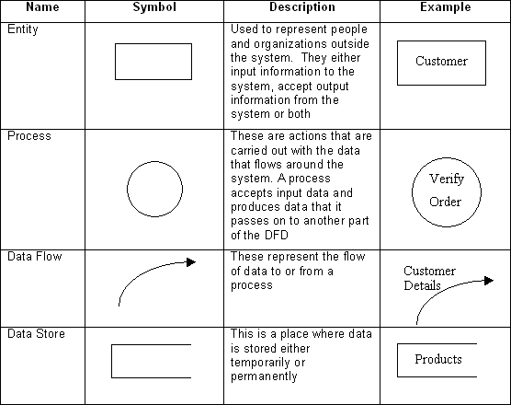

**Fig 3.1: Data Flow Diagram Symbols**

### DFD LEVEL0:

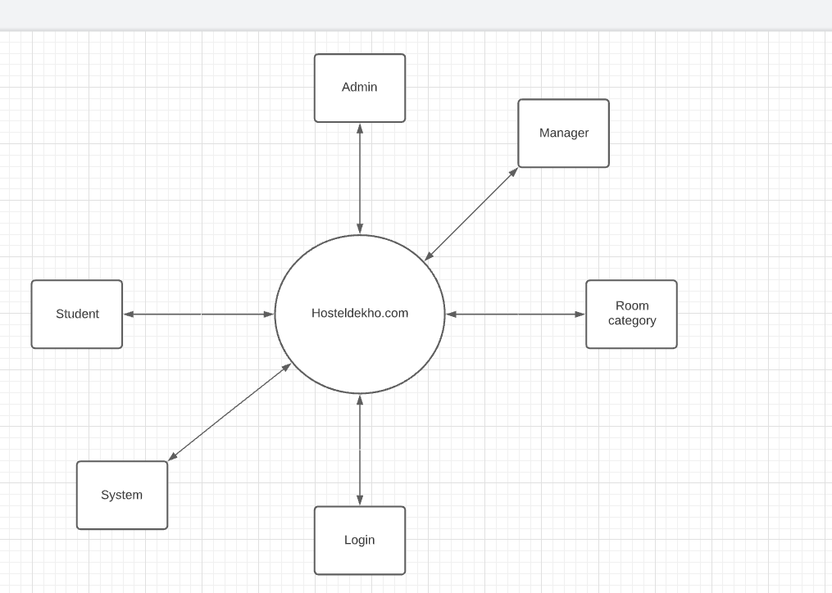

**Fig 3.2: 0 Level DFD**

### DFD LEVEL 1

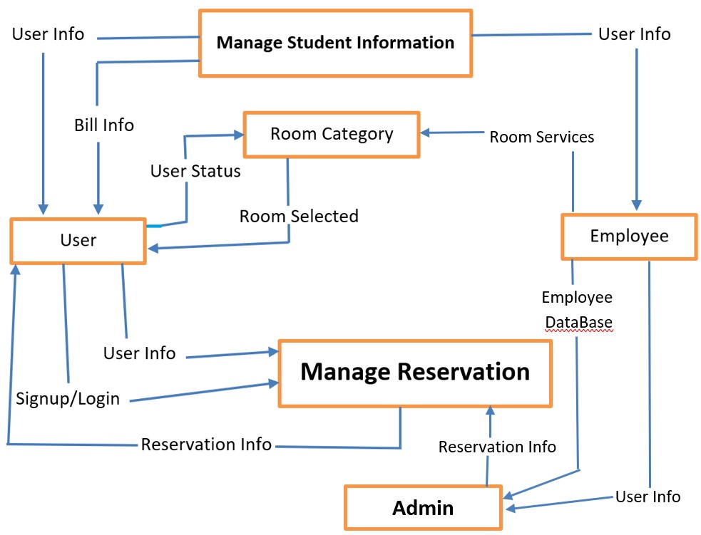

**Fig 3.3: 1 Level DFD**

### Entity Relationship Diagram (ER-Diagram):

An entity-relationship diagram (ERD) is a graphical representation of an information system that shows the relationship between people, objects, places, concepts or events within that system. An ERD is a [data modeling](http://searchdatamanagement.techtarget.com/definition/data-modeling) technique that can help define business processes and can be used as the foundation for a [relational database](http://searchsqlserver.techtarget.com/definition/relational-database).

While useful for organizing [data](http://searchdatamanagement.techtarget.com/definition/data) that can be represented by a relational structure, an entity-relationship diagram can't sufficiently represent semi-structured or [unstructured](http://searchbusinessanalytics.techtarget.com/definition/unstructured-data) [data,](http://searchbusinessanalytics.techtarget.com/definition/unstructured-data) and an ERD is unlikely to be helpful on its own in integrating data into a preexisting information system.

Three main components of an ERD are the [entities](http://whatis.techtarget.com/definition/entity), which are objects or concepts that can have data stored about them, the relationship between those entities, and the [cardinality,](http://whatis.techtarget.com/definition/cardinality) which defines that relationship in terms of numbers.

### Components of the ER Model:

The three main components of the ER Model are **entities**, **attributes**

and **relationships**.

* In ERM terms, an entity is a "thing" within the organization that we want to keep information about, such as a customer, employee or course. In other words, an entity in an ERM actually refers to a table, and rows within the table are referred to as entity occurrences. Entities are represented by rectangles containing the name of the entity. Entity names must be singular and in capital letters.
* Each entity has attributes which are the properties of each entity. Attributes will be implemented as columns in the tables.
* Each attribute has a domain which specifies the set of possible values an attribute can have. For instance, the range of values for a telephone extension may be specified as a set of integer numbers between 4000 and 4999. An attributes domain is not displayed in ER diagrams, but is recorded in the data dictionary.
* Attributes can be of various types. A composite attribute can be sub divided into smaller parts. For example, an attribute Name can be subdivided into First Name and Last Name. Attributes that cannot be subdivided are called simple attributes. First Name and Last Name are now simple attributes. Most attributes have only a single value and as such are called single valued attributes. For example, a Teacher can have only one Last Name or a Subject can have only one Subject Code. Multi- valued attributes can have more than one value. For example, a Student could have more than one Certificate or a Department may have several Extensions.
* A key attribute is an attribute that has a unique value for each entity occurrence. In other words, a key attribute is used to identify each row uniquely. For example, a Subject Code will uniquely identify each subject as no two subjects can have the same Subject Code. Key attributes are represented by underlining its name.
* A relationship is the association between entities or entity occurrences.

### ER Diagram of HostelDekho.com :

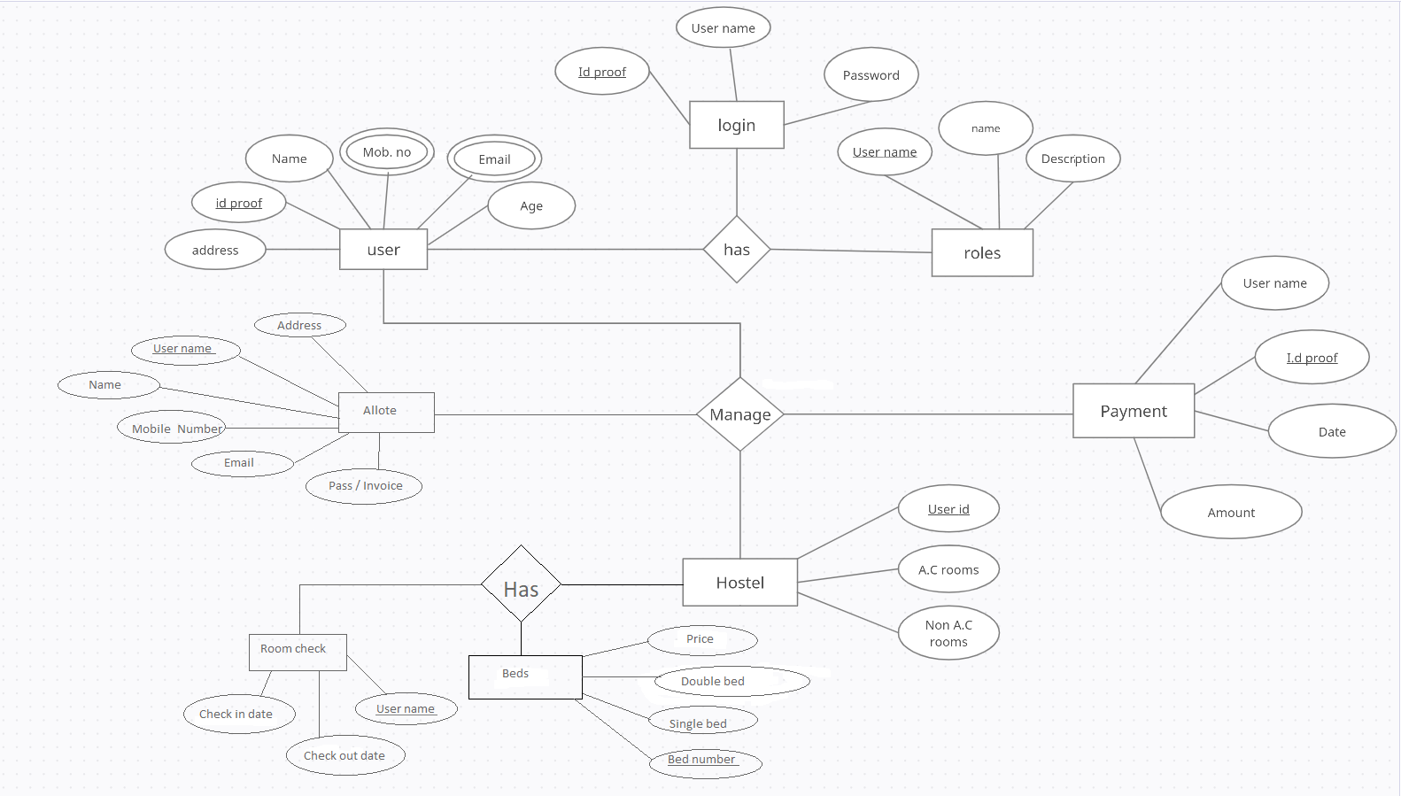

**Fig 3.4: Entity Relationship Diagram**

**GANTT CHART:**

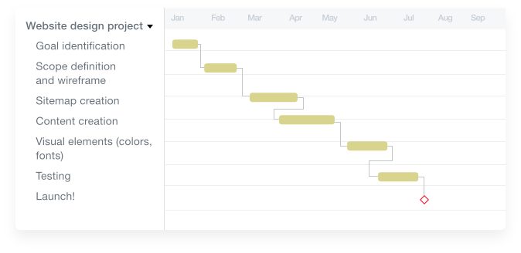

**Fig 3.5: Gantt Chart**

### Database Design:

A good database design is crucial for a high-performance application. Without optimized relationships, your database won’t perform as efficiently as possible. Thinking about relationships and database efficiency is part of normalization.

Beyond the issue of performance is the issue of maintenance your database should be easy to maintain. This includes storing only a limited amount (if any) of repetitive data. If you have a lot of repetitive data and one instance of that data undergoes a change (such as a name change), that change has to be made for all occurrences of the data. To eliminate duplication and enhance your ability to maintain the data, you might create a table of possible values and use a key to refer to the value. That way, if the value changes names, the change occurs only once in the master table. The reference remains the same throughout other tables.

**Table 3.1: Admin Login Table(adlogin)**

XXVI

|  |  |  |  |
| --- | --- | --- | --- |
| **Attribute** | **Type** | **Description** | **Constraints** |
| Id | int(10) | Admin Id | Primary Key |
| usname | varchar(30) | Username of admin | Not null |
| Password | varchar(30) | Password of Admin | Not null |

|  |  |  |  |
| --- | --- | --- | --- |
| **Attribute** | **Type** | **Description** | **Constraints** |
| sno | int(10) | Id Number of Student | Primary Key |
| Name | Varchar(100) | Name of Student | Not null |
| Phone | Bigint(10) | Phone Number of Student | Not null |
| Email | varchar(100) | Email of the Student | Not null |
| Course | varchar(50) | Course of Student | Not null |
| Hometown | varchar(50) | Hometown of Student | Not null |
| Alt_phone | bigint(10) | Mobile Number of the Student | Not null |
| Type_room | varchar(150) | Type of Room | Not null |
| Meal | varchar(30) | Meal Facility Status | Not null |
| Wifi | varchar(50) | Wifi Facility Status | Not null |
| Laundry | varchar(150) | Laundry Facility Status | Not null |
| Check_in | Date | Date of check-in | Not null |
| Check_out | Date | Date of Check-out | Not null |
| Timestamp | Timestamp | TimeStamp of booking | Not null |
| Stat | Varchar(20) | Status of Booking | Not null |
| Nodays | Varchar(20) | No . of Days | Not null |
| Hostel | Varchar(10) | Name of Hostel | Not null |
| Room_no | Varchar(20) | RoomNo. Alloted | Not null |

**Table 3.2: Booking Table(booking)**

**Table 3.3: Contact Details (contact)**

|  |  |  |  |
| --- | --- | --- | --- |
| **Attribute** | **Type** | **Description** | **Constraints** |
| Sno | int(10) | Serial No. | Primary Key |
| Name | varchar(200) | Name of Customer | Not null |
| Phone | Bigint(10) | Phone Number of Customer | Not Null |
| Email | Varchar(100) | Email of Customer | Not Null |
| Remarks | Varchar(100) | Remarks of Callback | Not Null |
| Time | Timestamp | TimeStamp of Query | Not Null |

**Table 3.4: Rooms Table (login)**

|  |  |  |  |
| --- | --- | --- | --- |
| **Attribute** | **Type** | **Description** | **Constraints** |
| Sno | int(10) | Id number of the Student | Primary Key |
| Name | varchar(100) | Name of Student | Not null |
| Phone | Bigint(100) | Phone Number of Student | Not Null |
| Mail | Varchar(100) | Mail-ID for Sending Mail | Not Null |
| Otp | Int(6) | 6-Digit OTP sent on Mail | Not Null |
| Time | Timestamp | Timestamp | Not Null |

**Table 3.5: Payment(payment)**

|  |  |  |  |
| --- | --- | --- | --- |
| **Attribute** | **Type** | **Description** | **Constraints** |
| Sno | int(10) | Id number of the room | Primary Key |
| Name | varchar(100) | Name of Student | Not null |
| Hostel | varchar(100) | Name of Hostel | Not Null |
| Troom | Varchar(100) | Type of Room | Not Null |
| Cin | Datetime | Check_in Date | Not Null |
| Cout | Datetime | Check_Out Date | Not Null |
| Noofdays | Int(100) | No. of Days | Not Null |
| Roomcharge | Int(100) | Room Charge | Not Null |
| Mealcharge | Int(100) | Meal Charge | Not Null |
| Wificharge | Int(100) | Wifi Charge | Not Null |
| Launcharge | Int(100) | Laundry Charge | Not Null |
| Total | Int(100) | Total Charge | Not Null |
| Room_no | Varchar(50) | Alloted Room Number | Not Null |

**Table 3.6: Rooms Table(room)**

|  |  |  |  |
| --- | --- | --- | --- |
| **Attribute** | **Type** | **Description** | **Constraints** |
| sno | int(100) | Serial Number of Room | Primary Key |
| Hostel_name | varchar(100) | Name of Hostel | Not null |
| Room_no | Varchar(100) | Room Number | Not Null |
| Status | Varchar(100) | Occupied/Unoccupied | Not Null |
| Type | Varchar(100) | Type of Room | Not Null |
| Price | Int(50) | Base Price of Room | Not Null |

# IMPLEMENTATION & USER INTERFACE

**Fig 3.6: Homepage of Website**

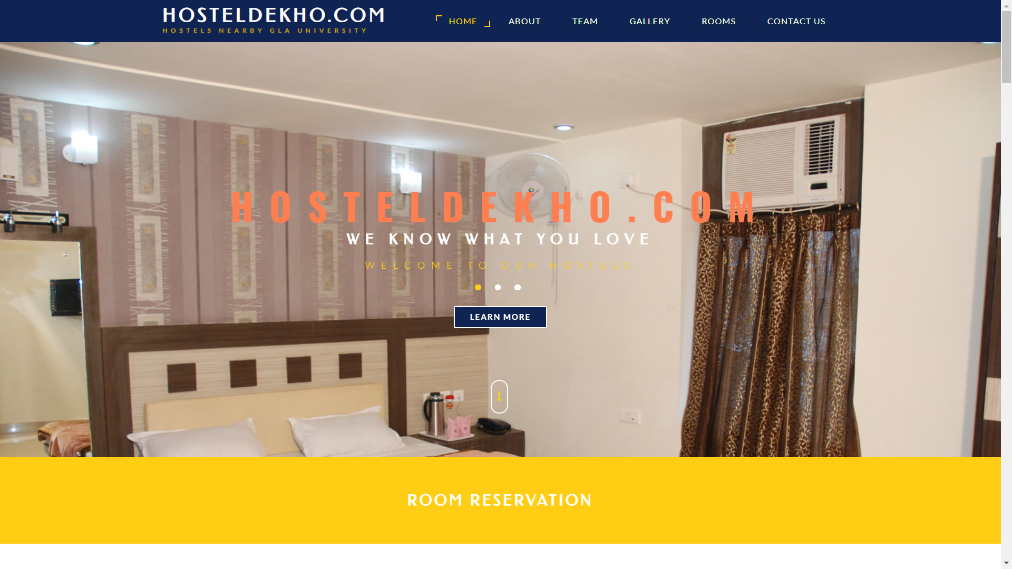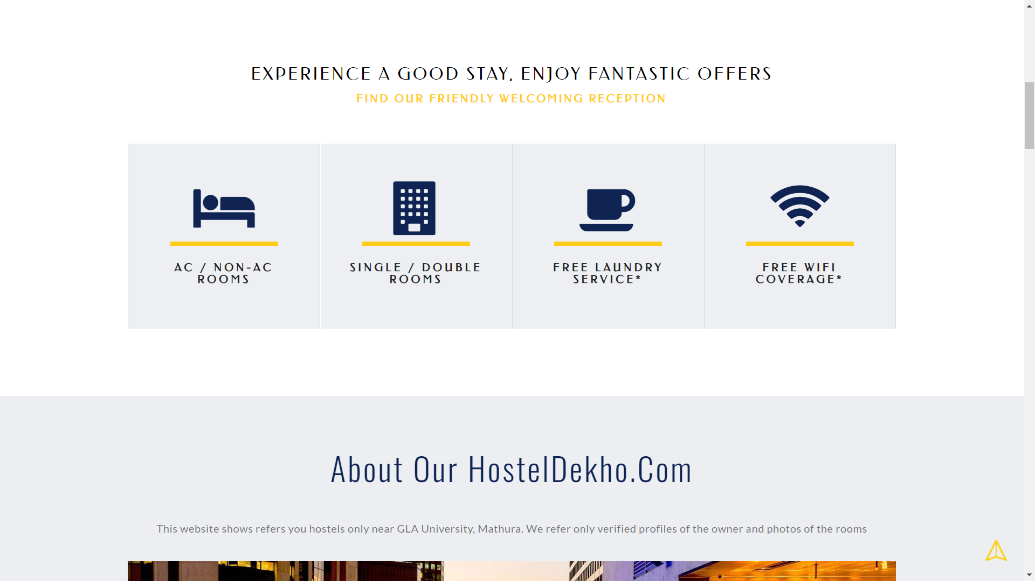

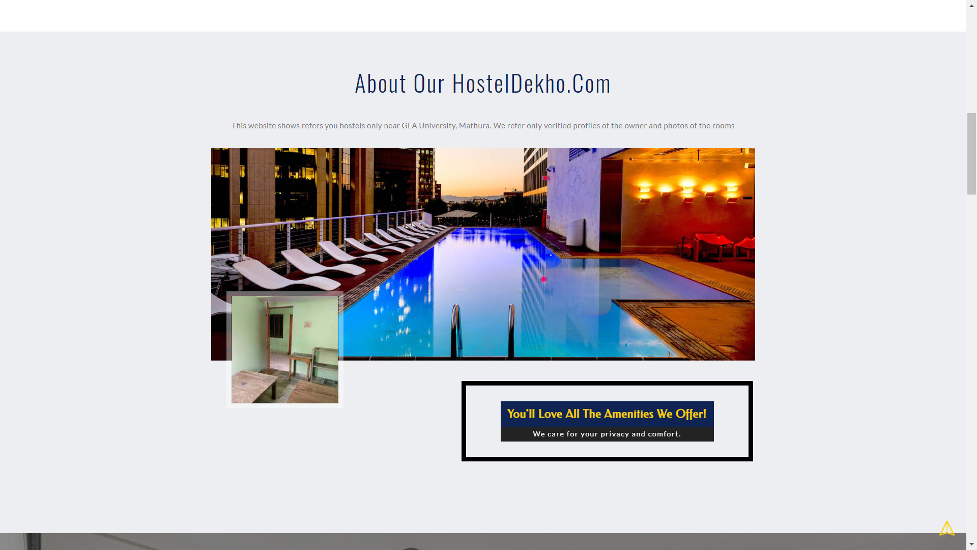

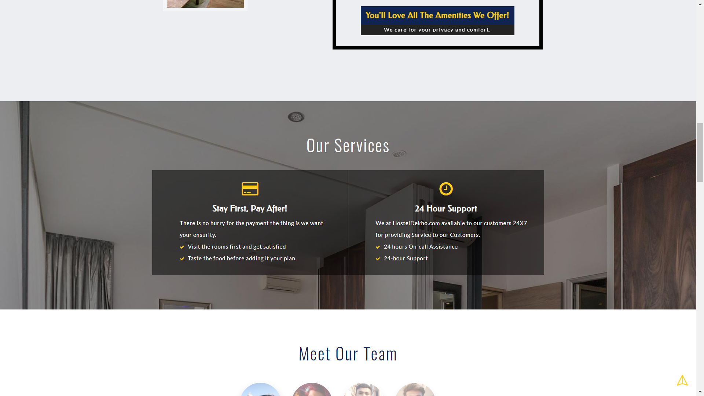

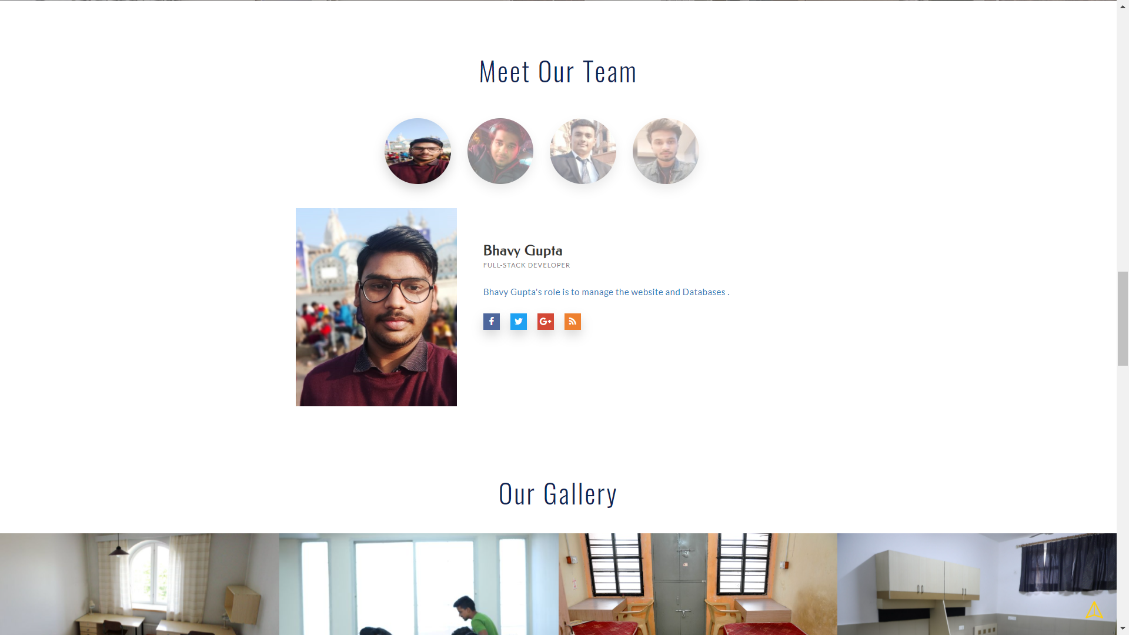

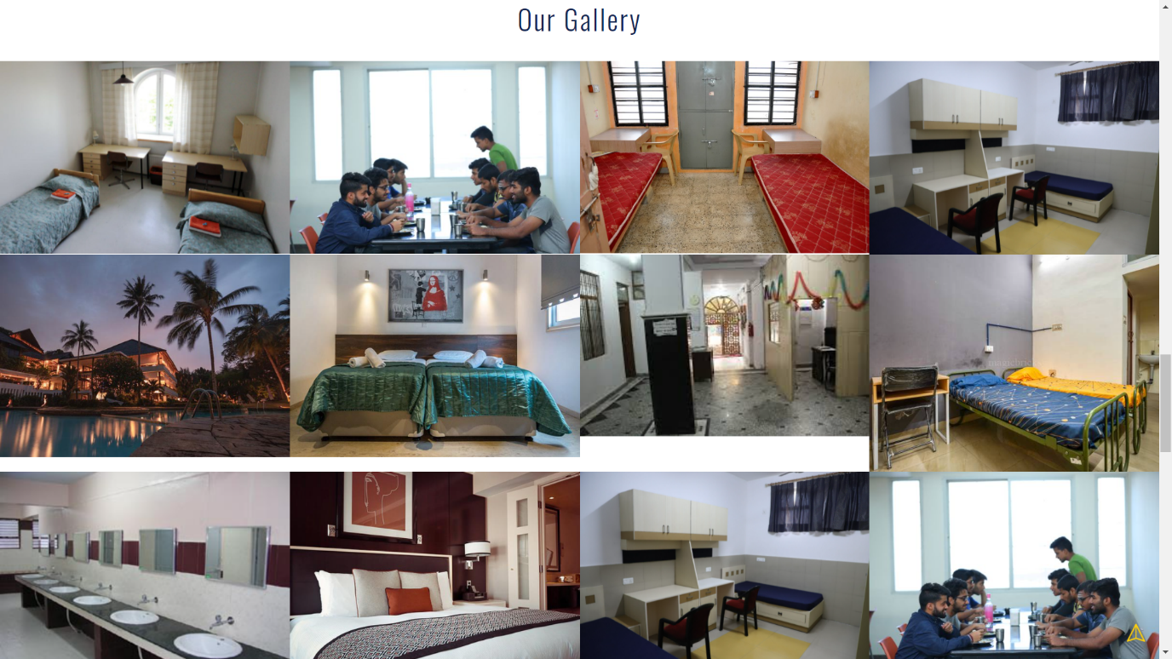

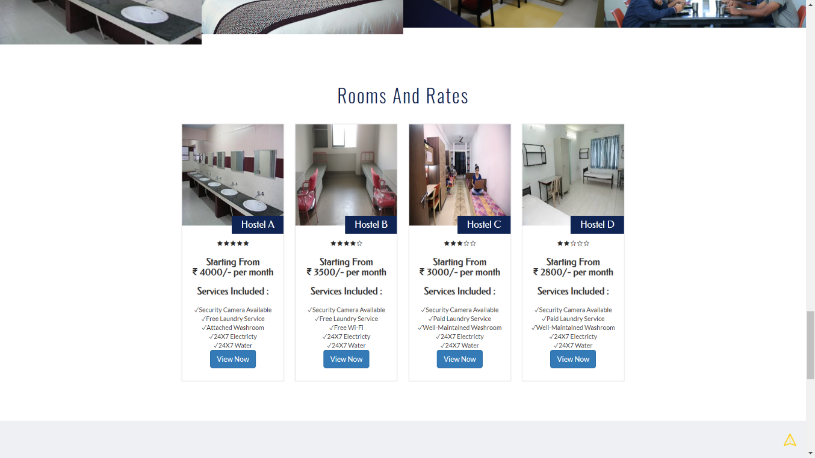

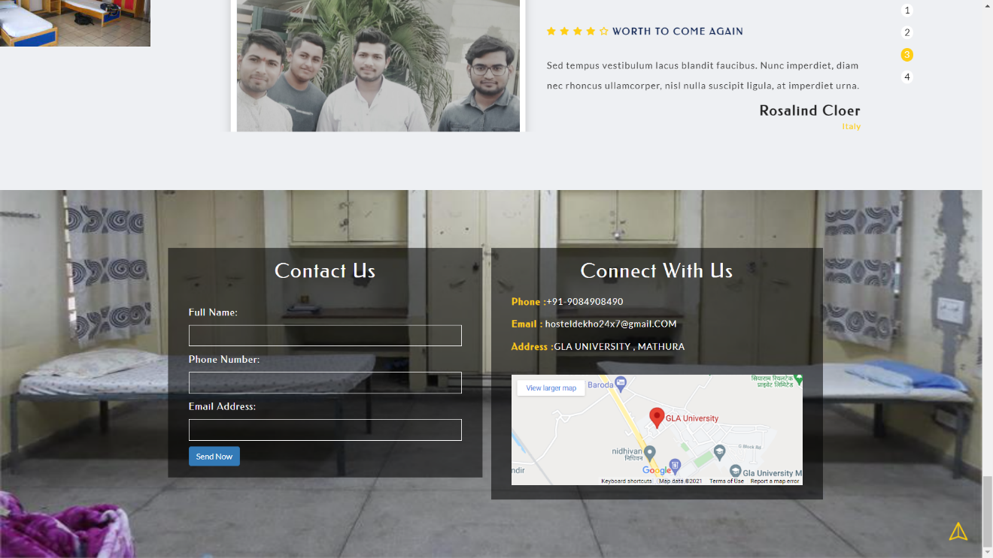

**Fig 3.7: Booking Interface**

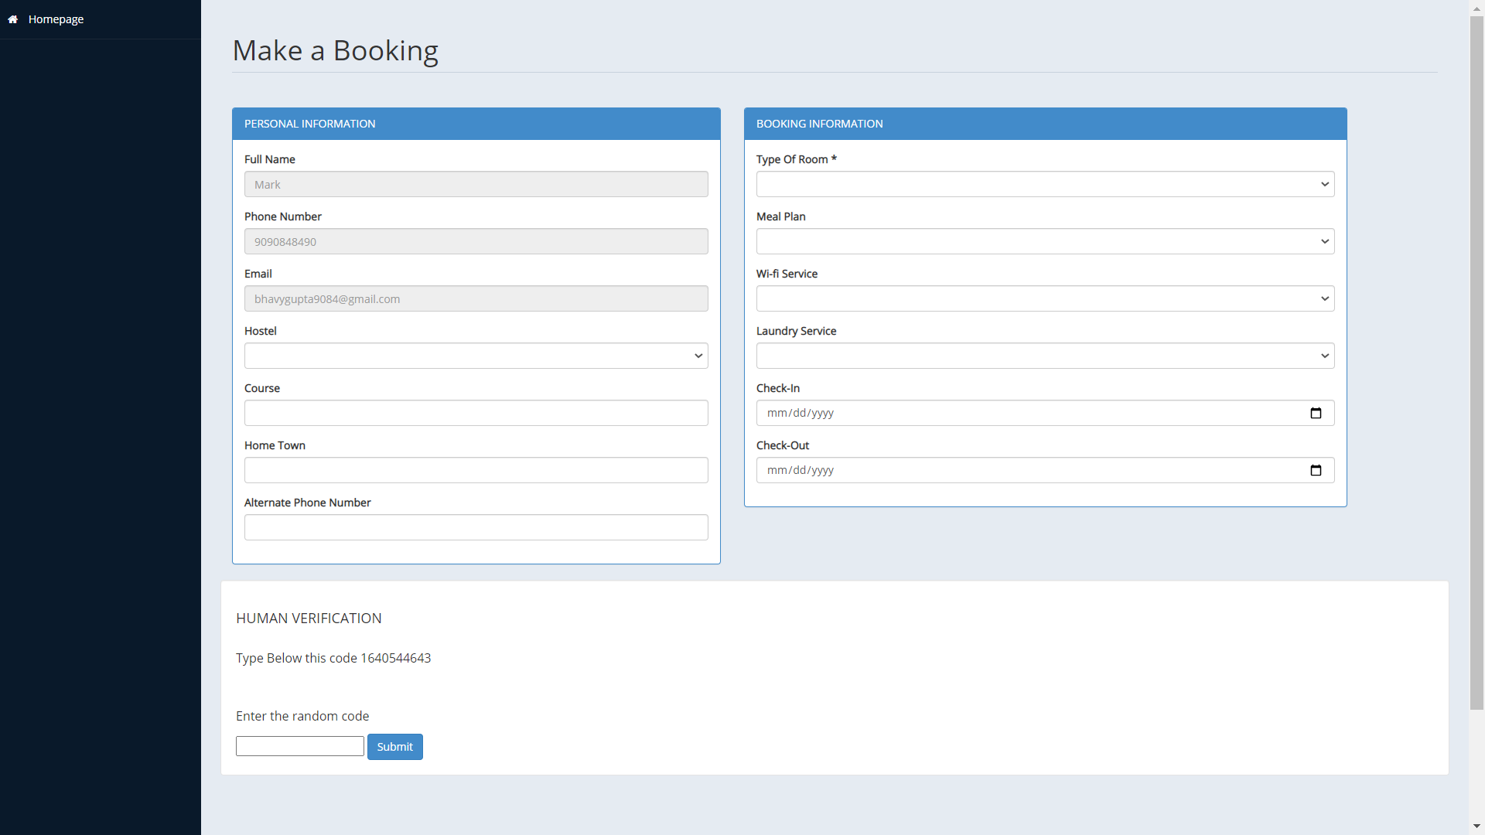

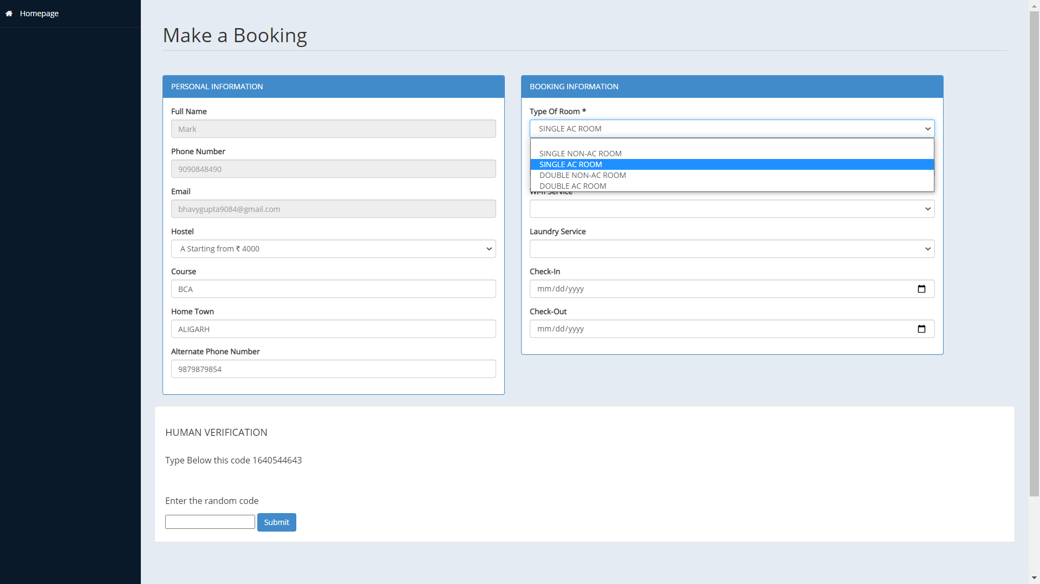

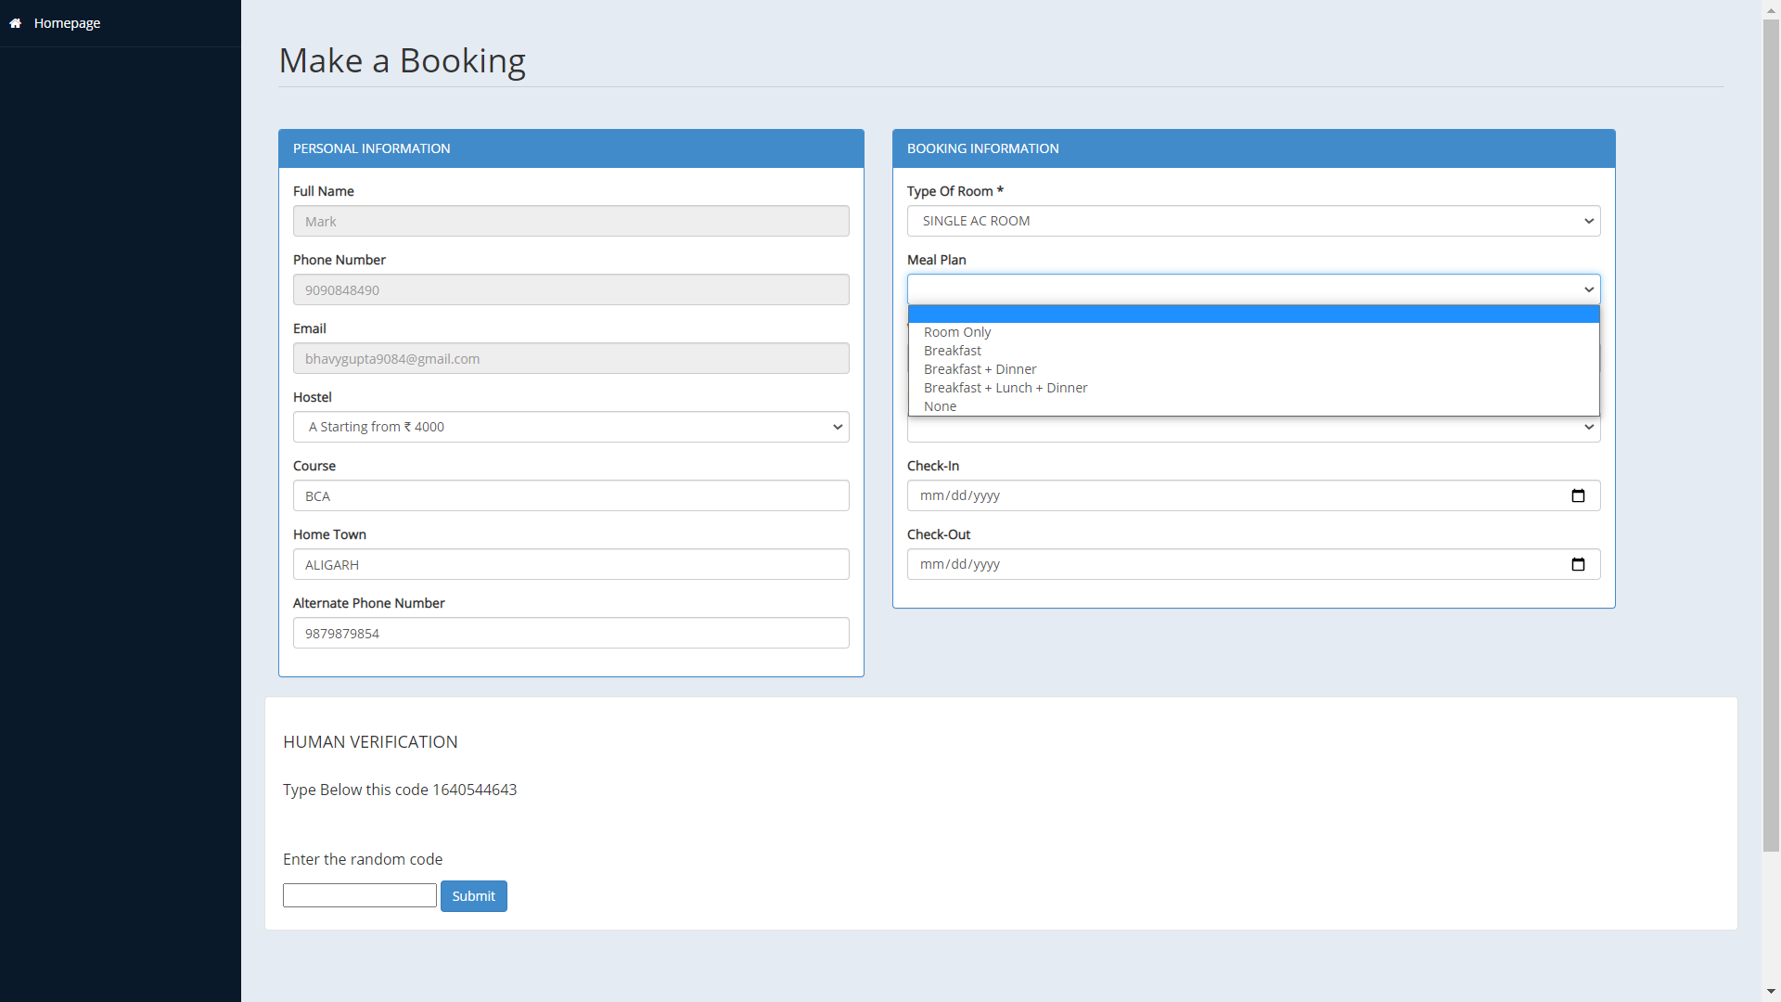

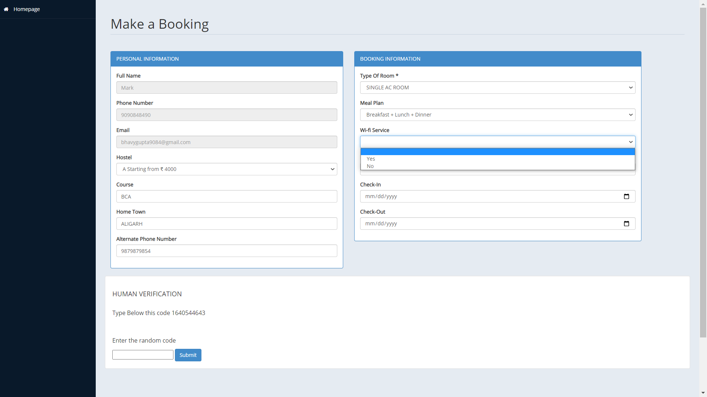



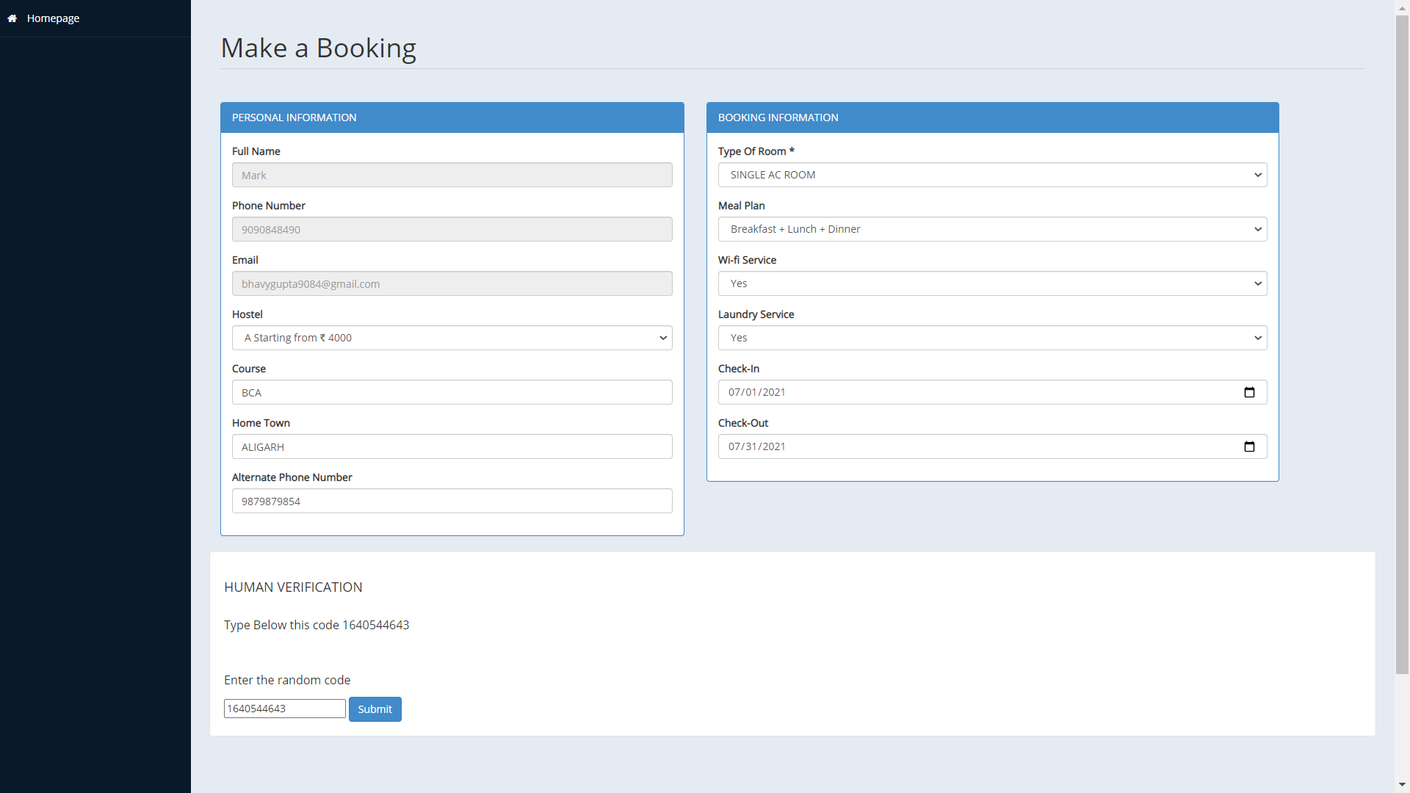

23



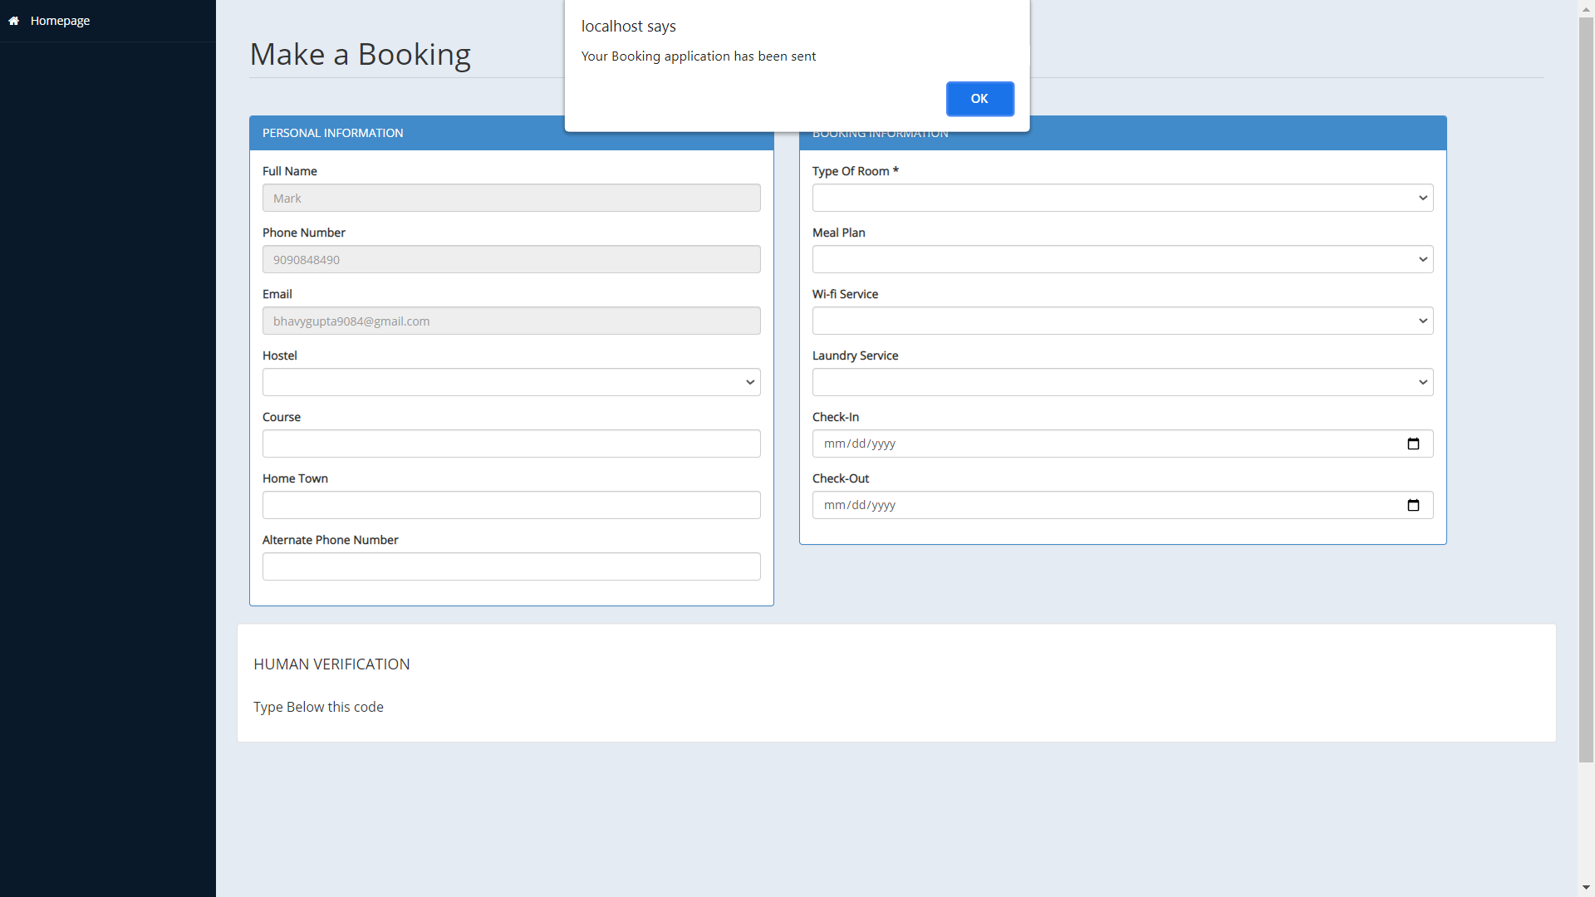

**Fig 3.9: Admin Panel**

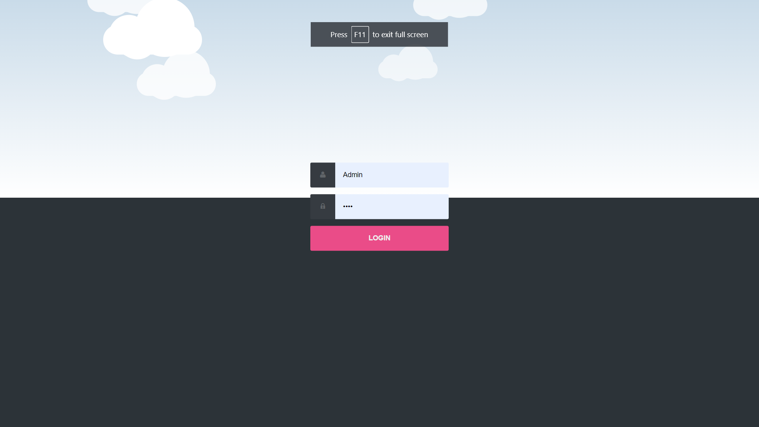

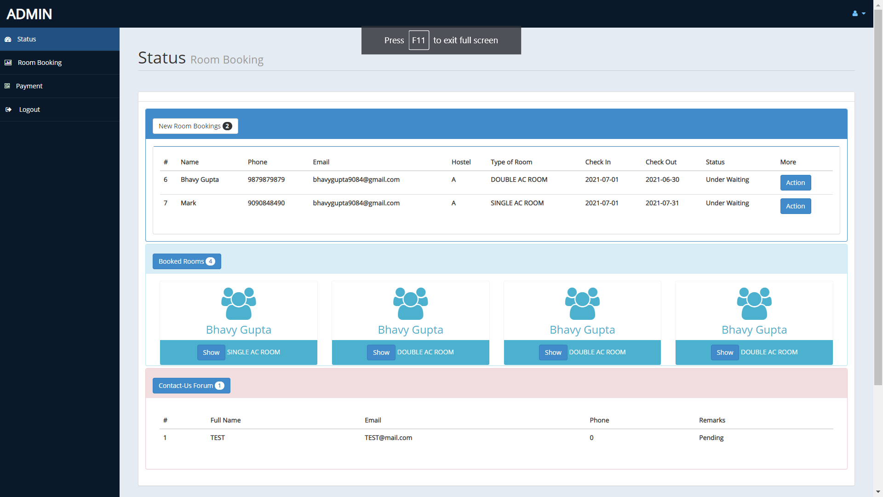

**Fig 3.10: Confirming Booking**

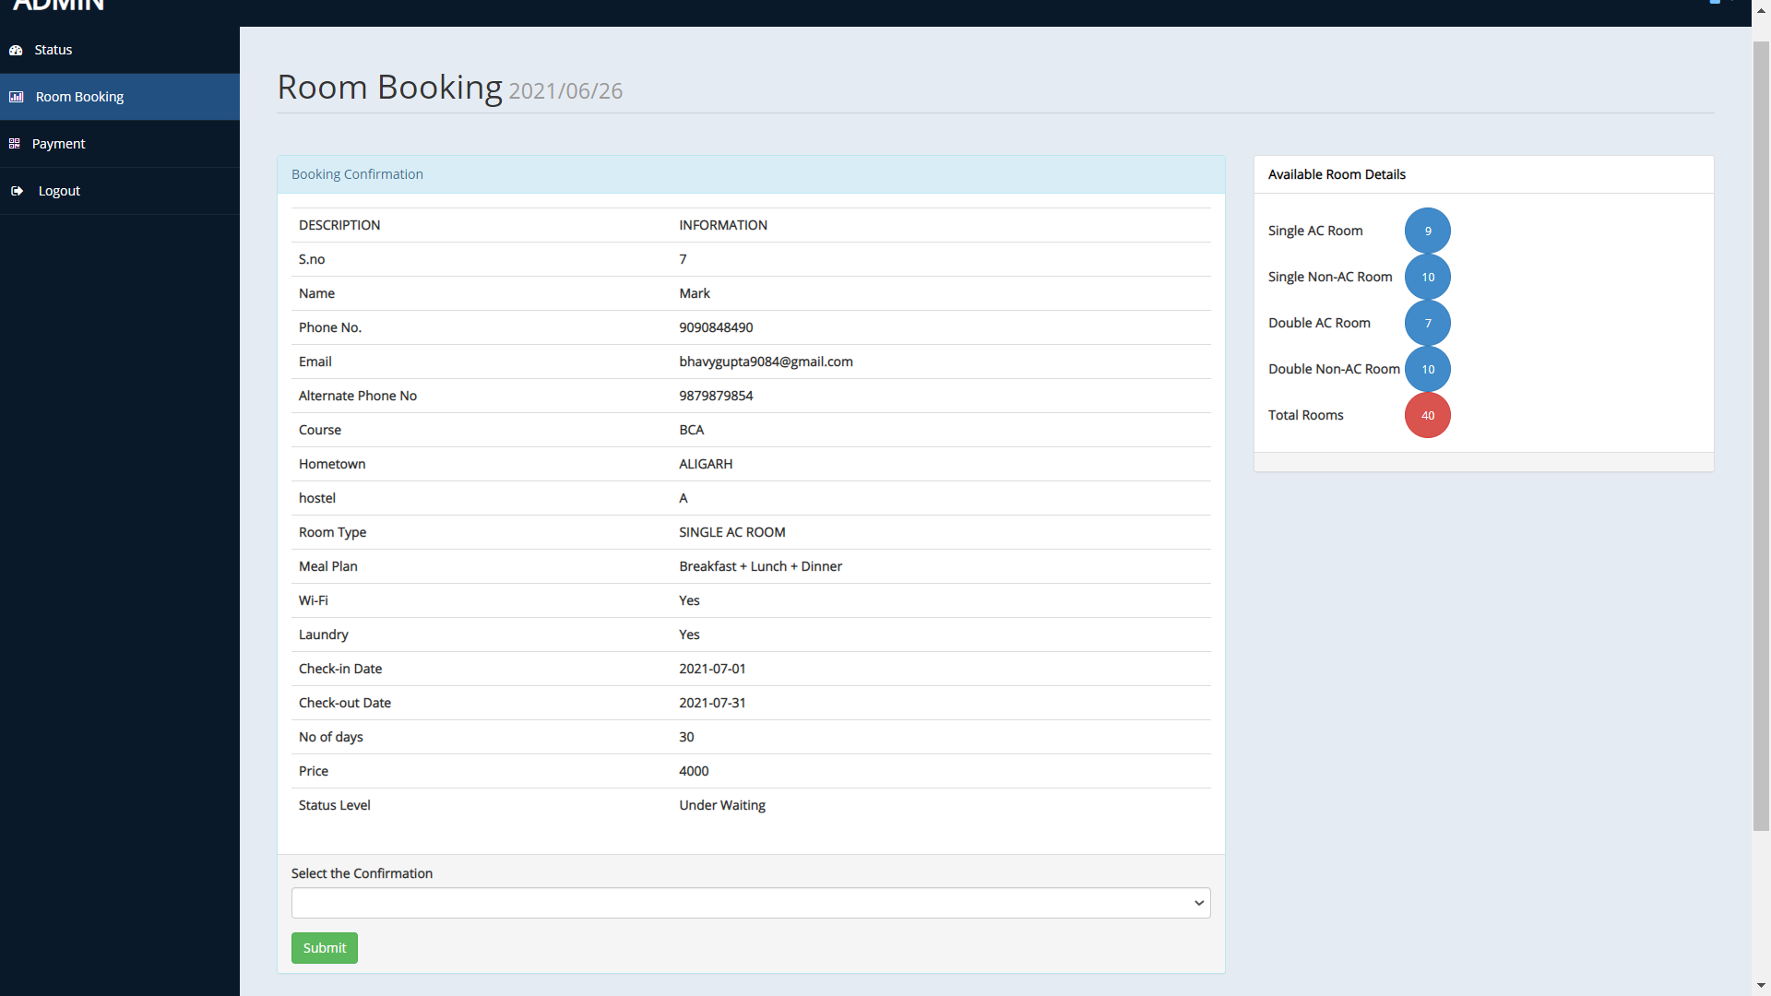

**Fig 3.11: Booking Confirmed Pop-up**

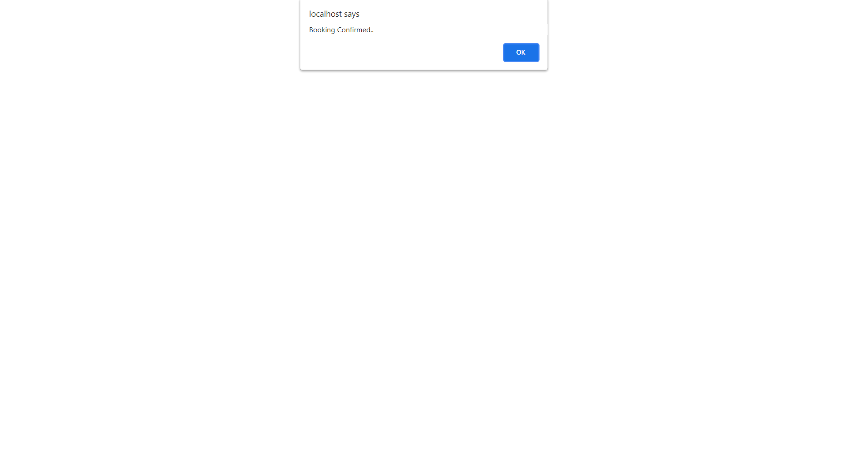

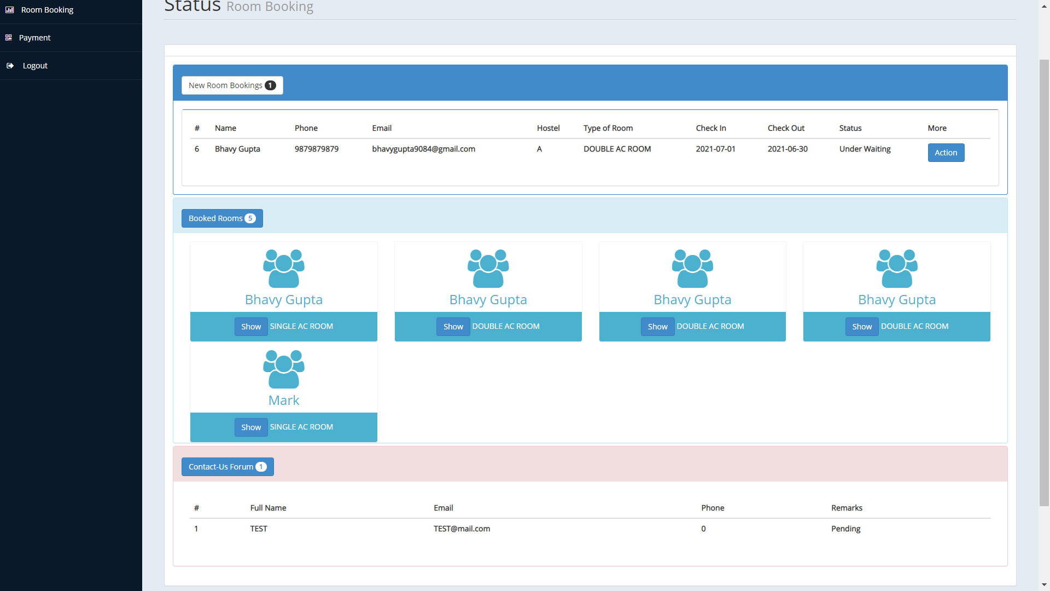

**Fig 3.12: Printing Student Details**

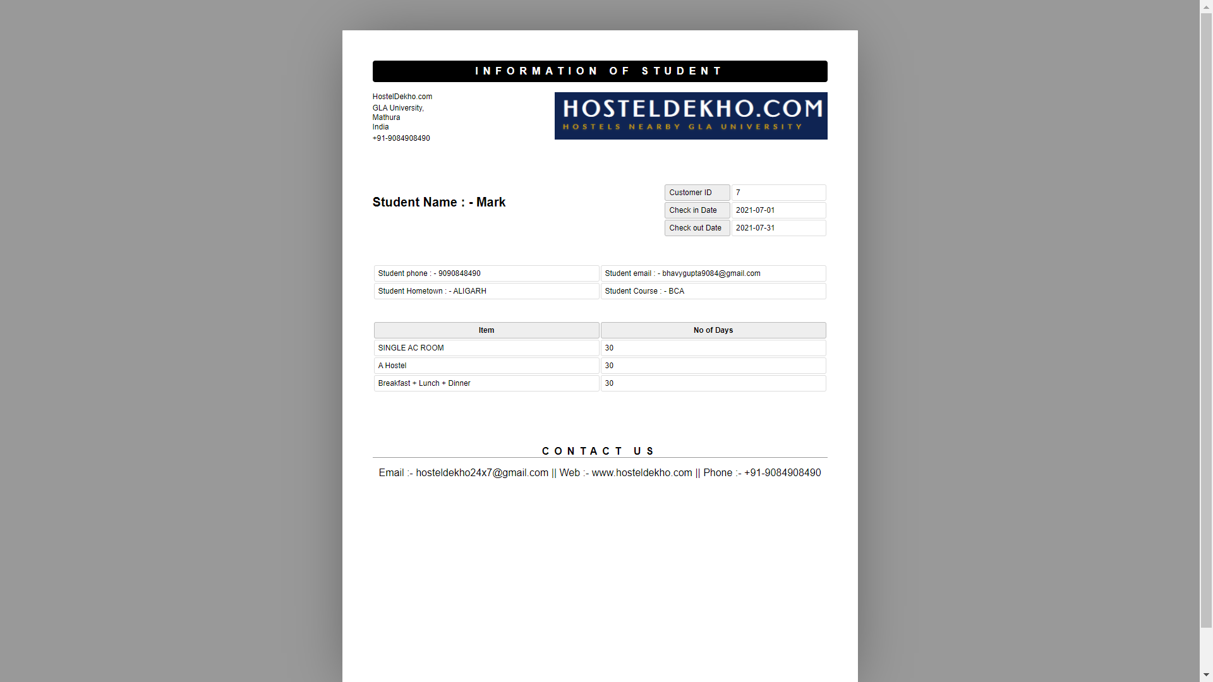

**Fig 3.13: Payment Portal**

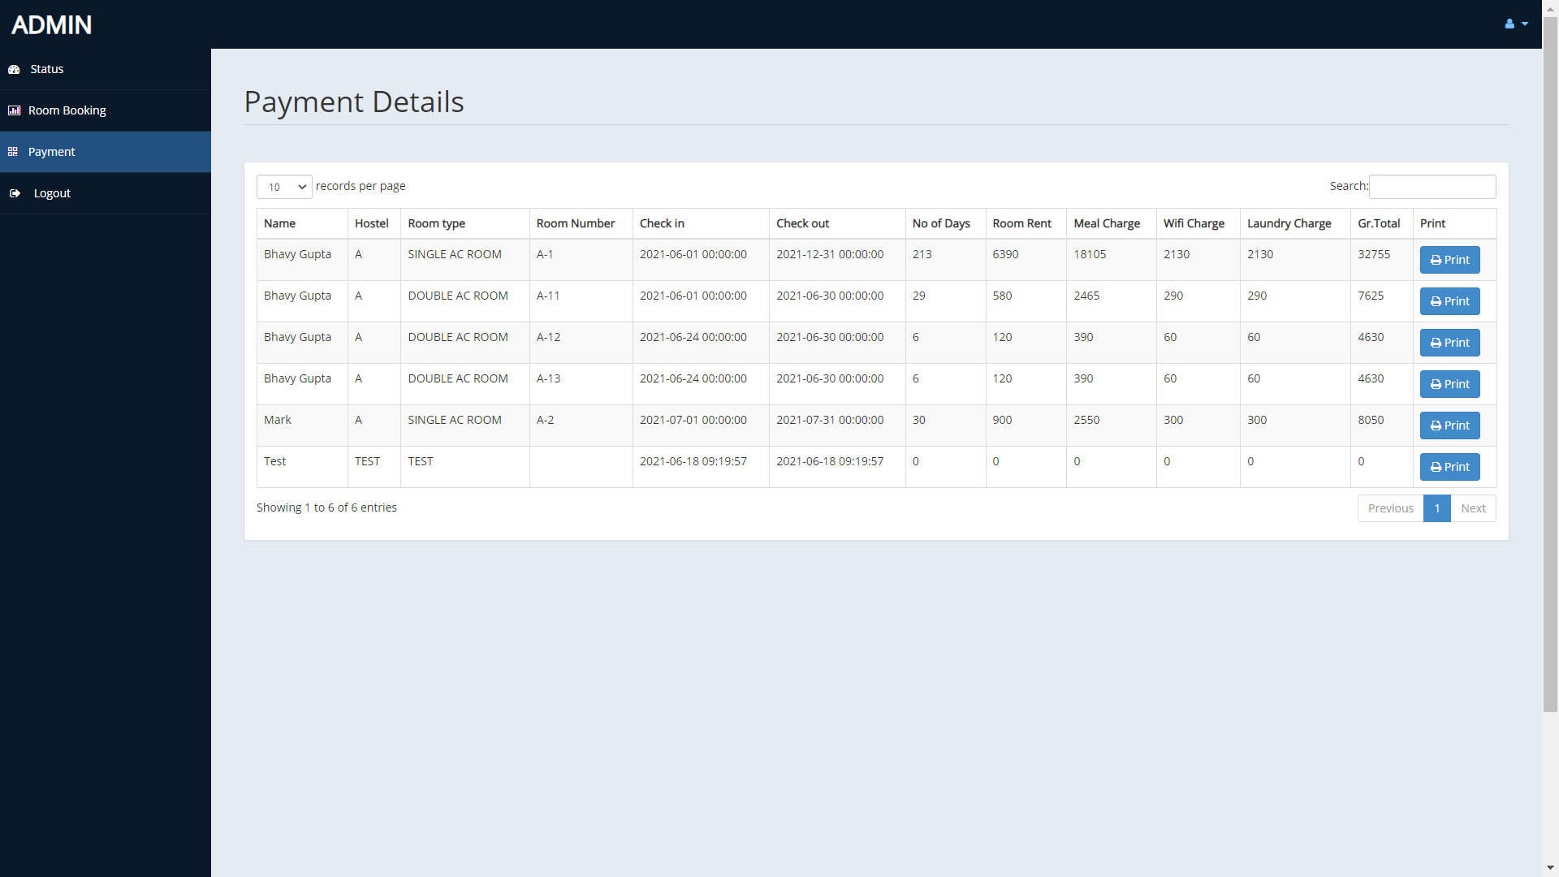

**Fig 3.14: Printing Invoice**

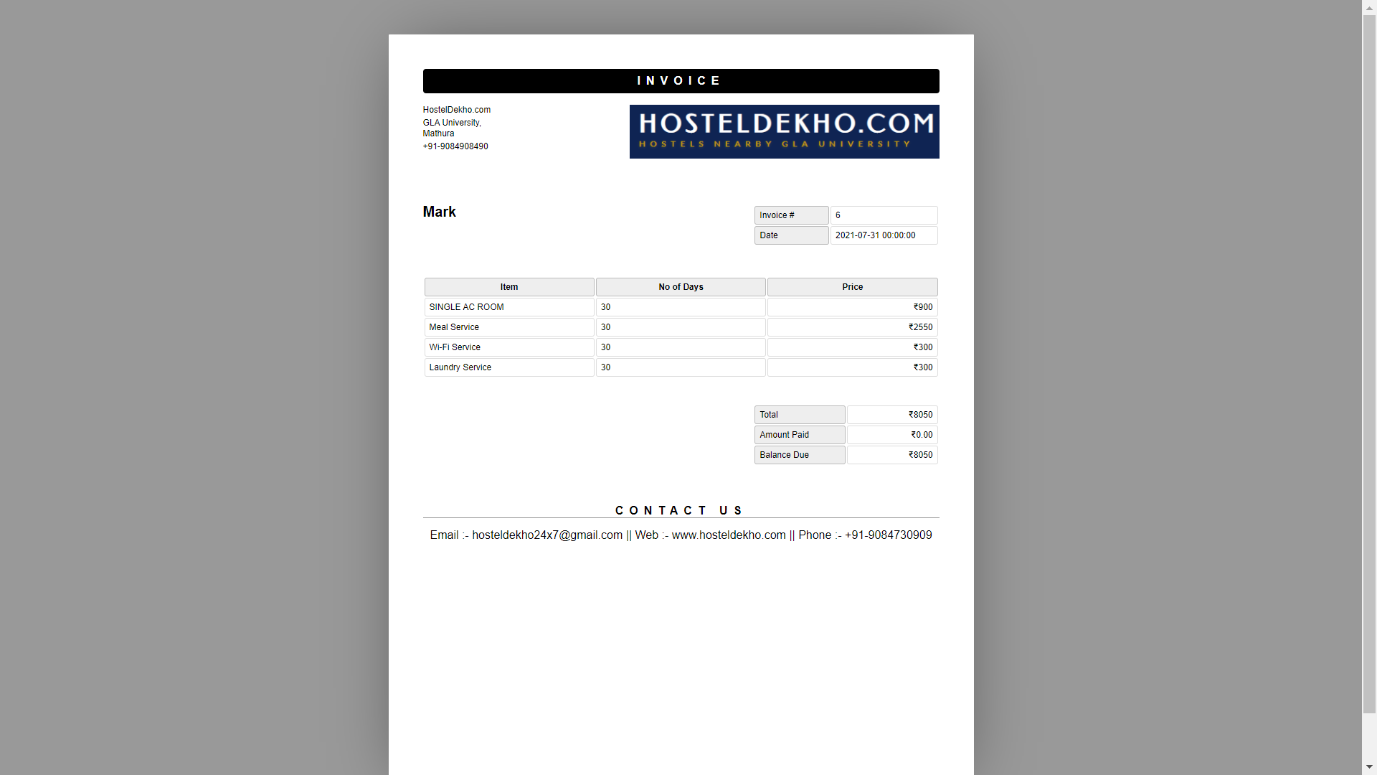

**Fig 3.15: Managing Admin Access**

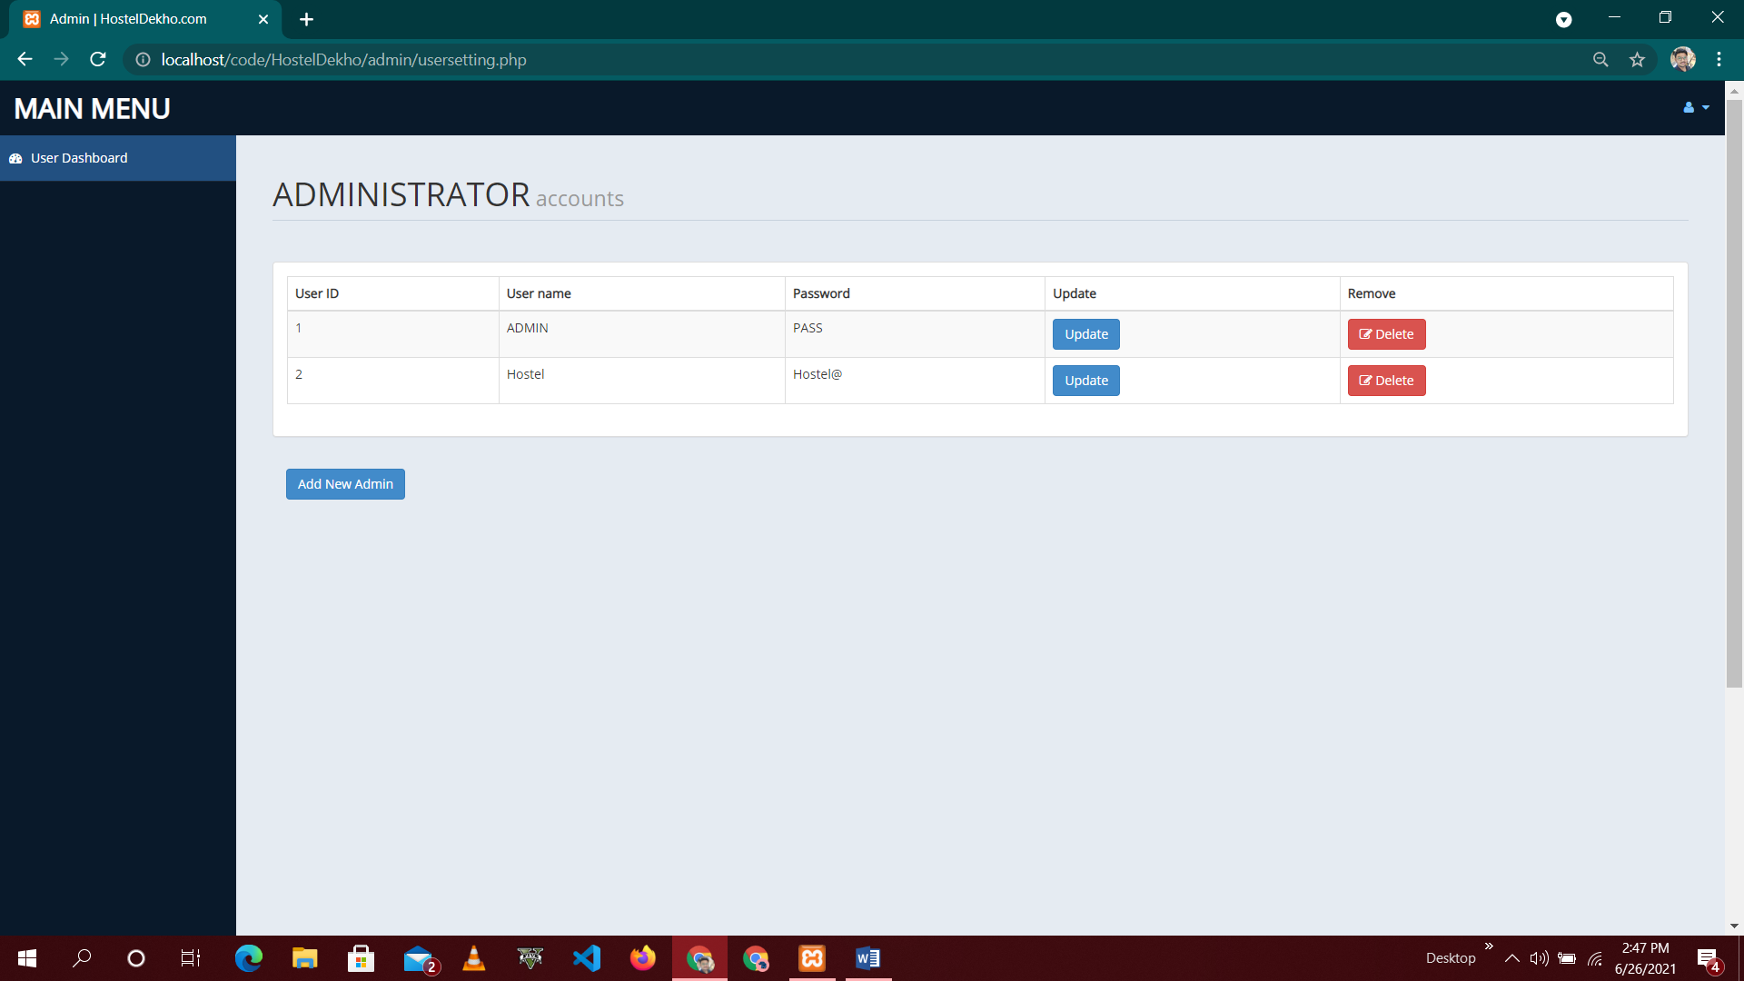

**Fig 3.16: Checking Available Rooms**

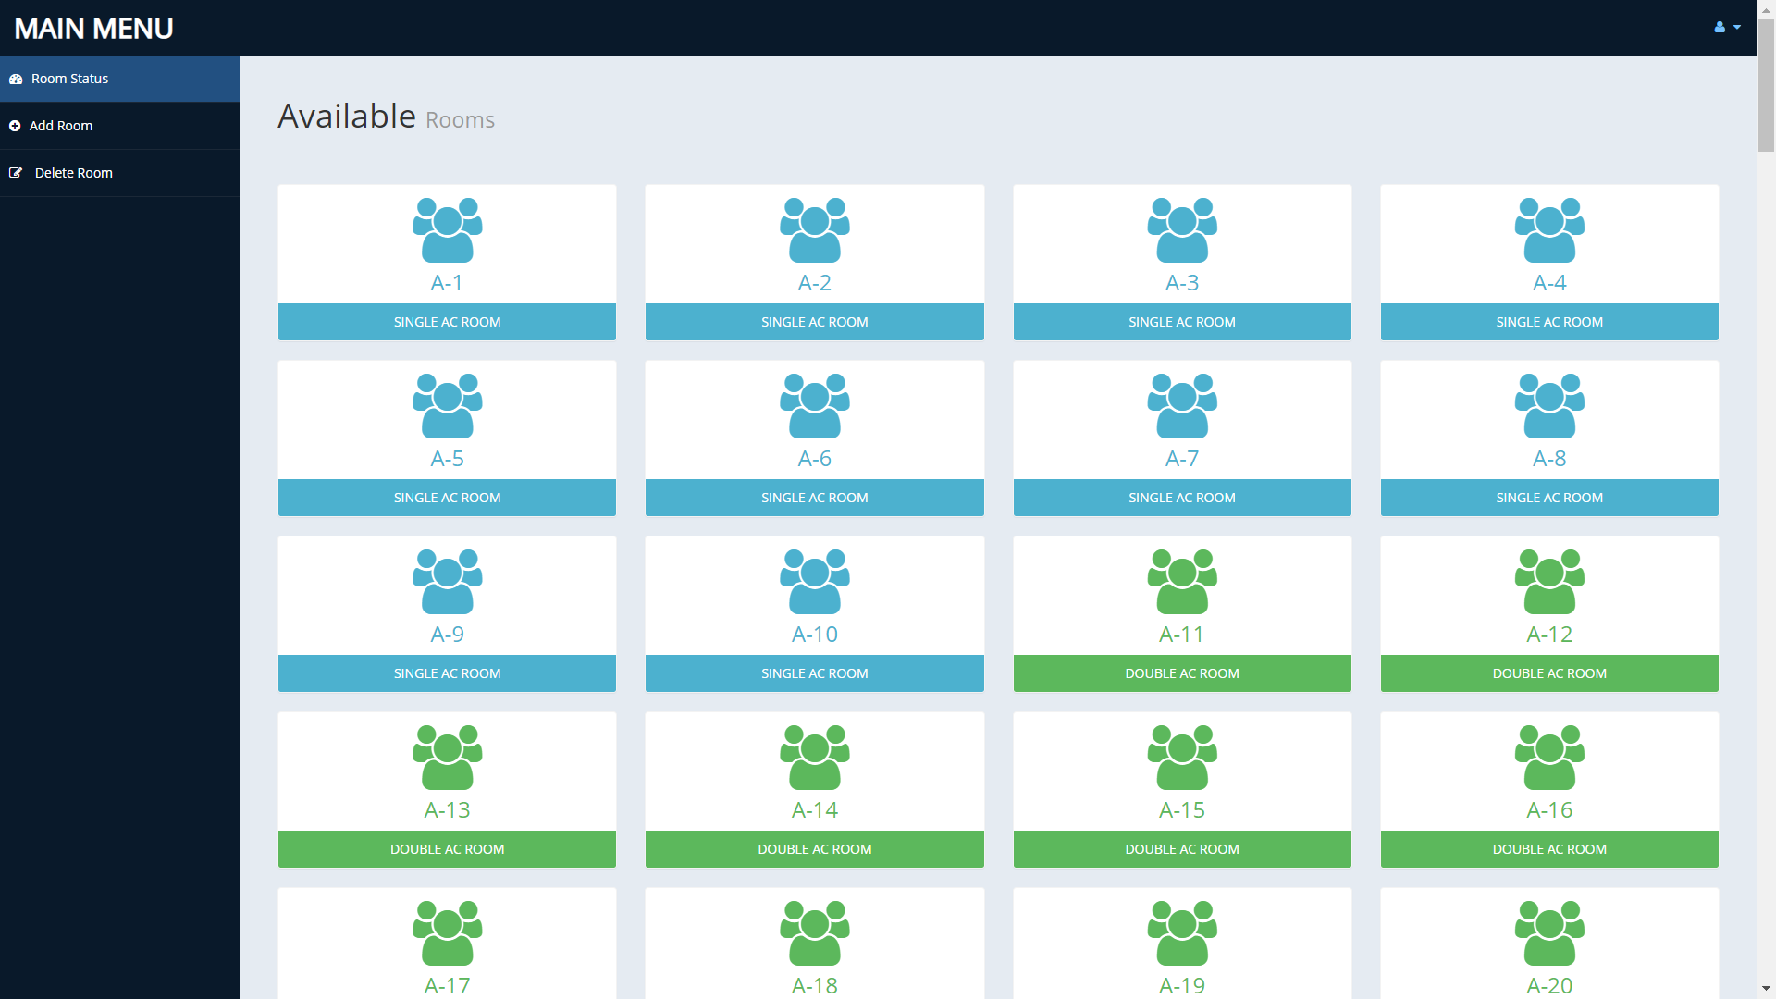

**Fig 3.17: Adding New Rooms**

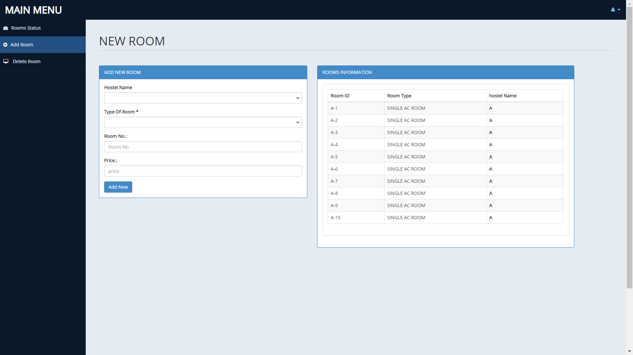

**Fig 3.18: Confirmation on Adding Room**

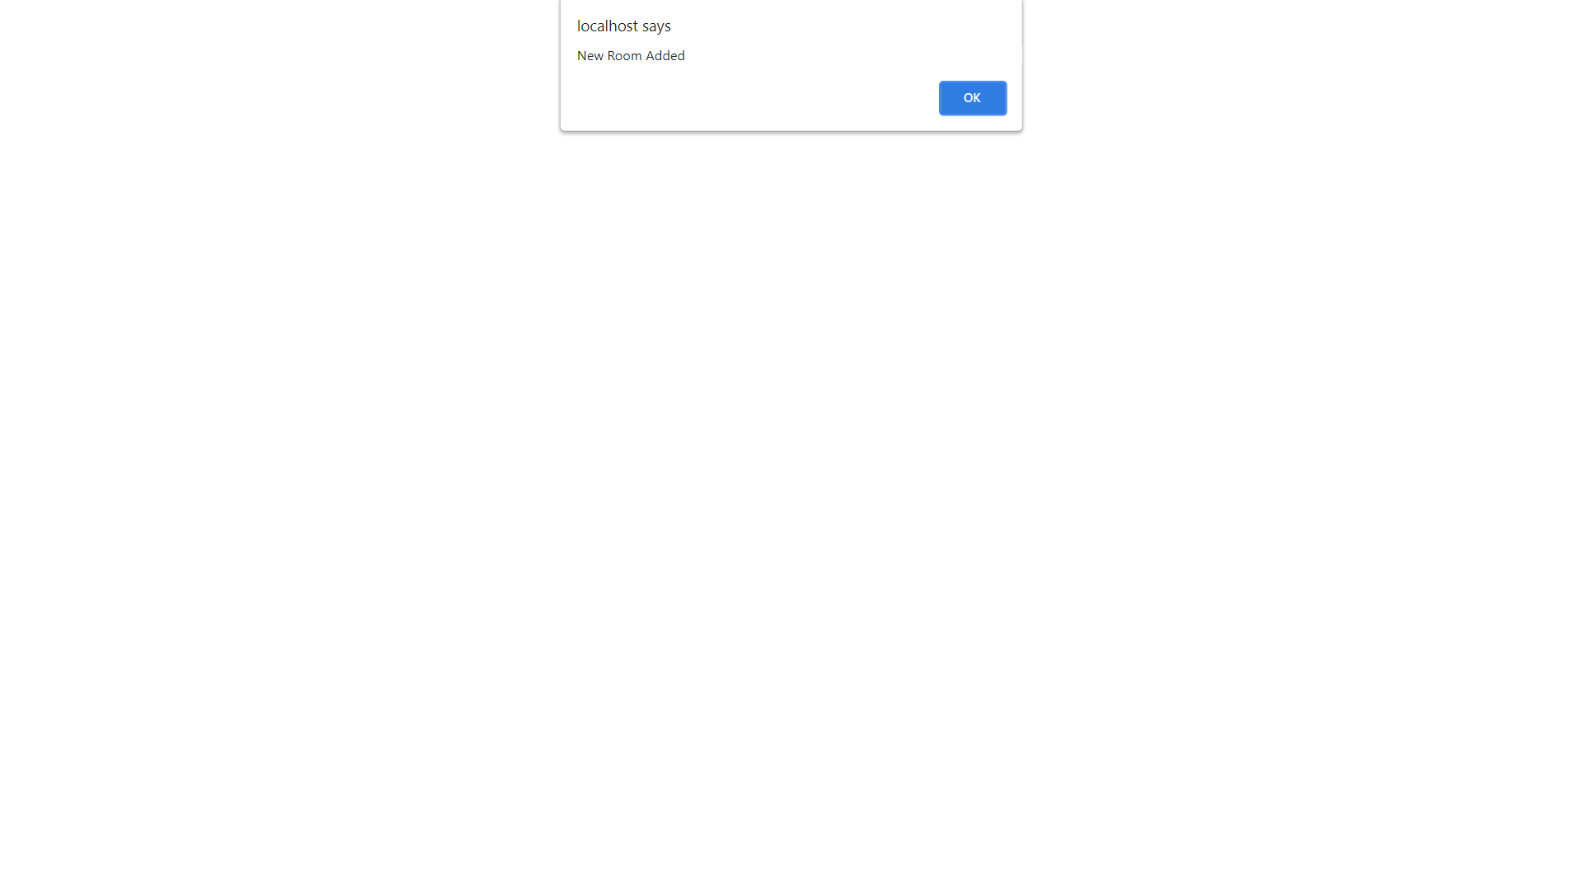

**Fig 3.19: Deleting Room**

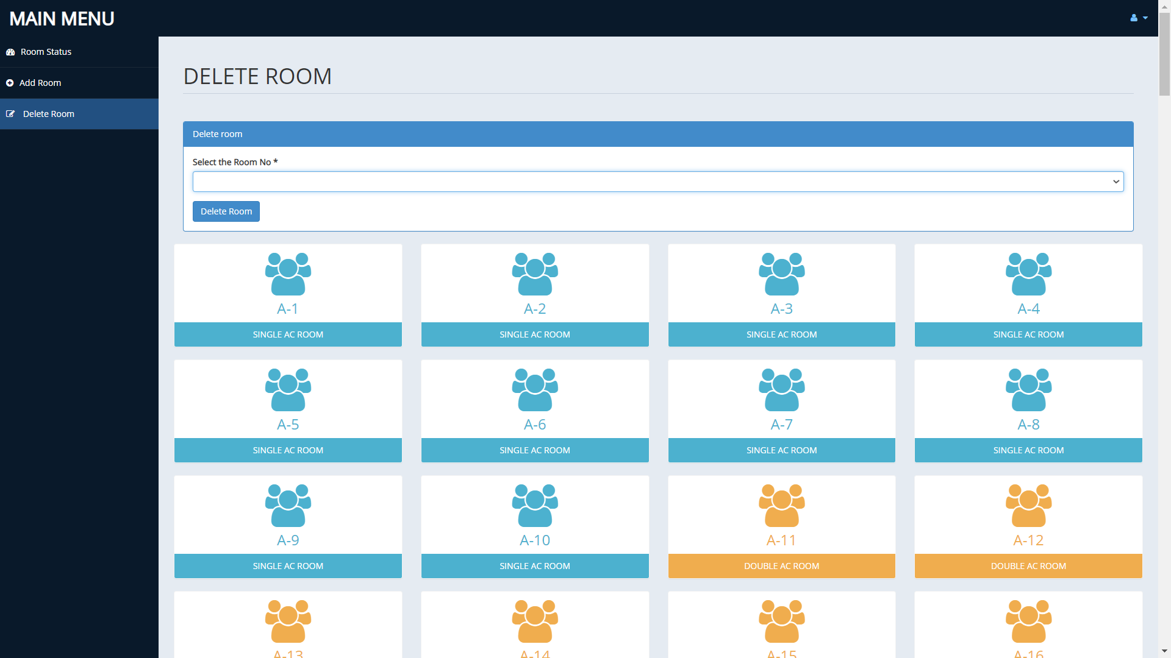

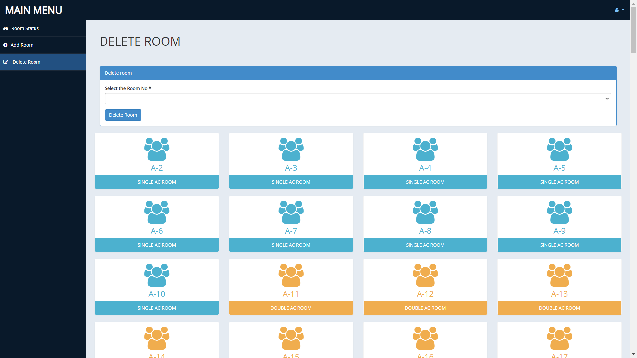

# SOFTWARE TESTING

### Testing:

* + - Software testing is the process of executing a program with intension of finding errors in the code. It is a process of evolution of system or its parts by manual or automatic means to verify that it is satisfying specified or requirements or not.
    - Generally, no system is perfect due to communication problems between user and developer, time constraints, or conceptual mistakes by developer.
    - To purpose of system testing is to check and find out these errors or faults as early as possible so losses due to it can be saved.
    - Testing is the fundamental process of software success.
    - Testing is not a distinct phase in system development life cycle but should be applicable throughout all phases i.e. design development and maintenance phase.
    - Testing is used to show incorrectness and considered to success when an error is detected.

### Objectives of Software Testing:

* + - **Software Quality Improvement:** The computer and the software are mainly used for complex and critical applications and a bug or fault in software causes severe losses. So a great consideration is required for checking for quality of software.
    - **Verification and Validation:** Verification means to test that we are building the product in right way .i.e. are we using the correct procedure for the development of software so that it can meet the user requirements.

Validation means to check whether we are building the right product or not.

* + - **Software Reliability Estimation:** The objective is to discover the residual designing errors before delivery to the customer. The failure data during process are taken down in order to estimate the software reliability.

### Principles of Software Testing:

* + - All tests should be traceable to end user requirements.
    - Tests should be planned long before testing begins
    - Testing should begin on a small scale and progress towards testing in large
    - To be most effective testing should be conducted by an independent third party.

The primary objective for test case design is to derive a set of tests that has the highest livelihood for uncovering defects in software. To accomplish this objective two different categories of test case design techniques are used. They are :

* + - **White Box Testing:** White box testing focus on the program control structure. Test cases are derived to ensure that all statements in the program have been executed at least once during testing and that all logical conditions have been executed.
    - **Black Box Testing:** Black box testing is designed to validate functional requirements without regard to the internal workings of a program. Black box testing mainly focuses on the information domain of the software, deriving test cases by partitioning input and output in a manner that provides through test coverage. Incorrect and missing functions, interface errors, errors in data structures.

### Testing fundamentals:

Testing is a process of executing program with the intent of finding error. A good test case is one that has high probability of finding an undiscovered error. If testing is conducted successfully it uncovers the errors in the software. Testing cannot show the absence of defects, it can only show that software defects present.

### Testing Information flow:

Information flow for testing flows the pattern. Two class of input provided to test the process. The software configuration includes a software requirements specification, a design specification and source code.

Test configuration includes test plan and test cases and test tools. Tests are conducted and all the results are evaluated. That is test results are compared with expected results. When erroneous data are uncovered, an error is implied and debugging commences.

# CONCLUSION

This was the first considerably large and important project undertaken by me during my BCA course. It was an experience that changed the way I perceived project development. The coding could not be started before the whole system was completely finalized. Even then there were so many changes required and the coding needed to be changed. I attribute this to inadequate information gathering from the user. Though there were many meetings with the user and most of the requirements were gathered, a few misinterpretations of the requirements still crept in. It made me realize how important the systems analysis phase is. The project is a classic example, that learning of concepts needs to be supplemented with application of that knowledge.

On the whole it was a wonderful experience developing **HostelDekho.com** and I would have considered my education incomplete without undertaking such a project which allowed me to apply all that I have learnt and tried to develop a project that can be useful for Students and parents to find their children’s hostel more easily and efficiently. It is developed using PHP so that it can be accessed very easily and at any time. The system will be capable of providing a particular serviceman to the users according to their needs within a given time frame. The system is developed with an aim of usability so that it is an easy to use system that requires the least amount of user input possible. For using this system general computer knowledge is enough. An easy well-structured module will show the correct path to reach the destination. Users will be authenticated to ensure that no unauthorized users gain access to private information.

# BIBLIOGRAPHY & REFERENCES

To develop this web application of HostelDekho.com, we used HTML, CSS, JavaScript for front-end, and PHP and MySQLi for Back-end(Database). We gathered some technical information from the below mentioned books and some reference from the internet which is mentioned below:

* The Joy of PHP Programming: A Beginner’s Guide by Alan Forbes
* PHP & MySQL Novice to Ninja by Kevin Yank

References:

* [www.w3schools.com/php.net](http://www.w3schools.com/php.net)
* [www.stackoverflow.com](http://www.stackoverflow.com/)
* [www.php.net-tutorial.com](http://www.php.net-tutorial.com/)
* [www.w3schools.com/css](http://www.w3schools.com/css)